

SRM Programme
Business System Design
Merchandising Group Maintenance

For sign-off:
Ewen MacInnes | Space, Range & Merchandising Programme Director
Neil Hollins | Head of Space
Nick Robbins | IT SRM Project Manager
Nick Michell | Range Programme 2 Project Manager
Jim Clifton | Planning & Change Manager, SRM
Copied for information:
Danielle Coe | Range Programme 3 Project Manager
Mark Croft | Ranging Controls Manager
Steve Player | Global Technical & Architecture Team (GT&A)
Geoff Olding | Space, Range and Merchandising (SRM) Testing Manager
Nick Robbins | IT SRM Project Manager
Meryl Hanlon | IT SRM Project Manager
Richard Cox | IT Xansa Project Manager

Author: Anne Broderick, Sue Buchanan
Date: May 2006
Version: 5.0

Amendment Control
Date | Author | Change Description | Version
28/05/04 | ALB | Initial Document | 00.1
15/07/04 | ALB | Updated for issue following team feedback | 01.0
09/05/05 | ALB | Amended following 2005 review of reqts. | 02.0
31/05/05 | ALB | Amended following internal team review | 02.1
16/06/05 | ALB | Amended following walkthru & feedback | 02.2
04/08/05 | ALB | Amended to incorp. final changes | 02.3
21/09/05 | ALB | Amended - Infrastructure now a separate project | 03.0
19/12/05 | NM | Amended – screen rationalisation following review | 03.1
06/01/06 | ALB | Amended – tidied up messaging, security etc | 03.2
01/03/2006 | ALB/IM | Revised, As-Is and To-Be diagrams added | 04.0
22/05/06 | SB | Base-lined for issuing to HSC:  - New mgp effective date set to ‘today’ and removed from users’ view  - Mgp deletion tied to an Event  - Removed duplicate screens | 5.0

Contents

1 INTRODUCTION 5
1.1 Management Summary 5
1.1.1 Purpose of this Document 5
1.1.2 Objectives of the Project 5
1.1.3 Background 5
1.2 Ranging Controls Overview 6
1.2.1 Ranging Controls System Overview 6
1.2.2 Application Overview 7
1.3 Merchandising Group Maintenance Application Overview 7
1.3.1 Deliverables 7
1.3.2 Benefits 7
1.3.3 Assumptions 8
1.3.4 Scope 8
2 The “AS IS” System 9
2.1 Process Overview 9
2.2 Process Description 10
2.2.1 Create a New Merchandising Group 10
2.2.2 Amend a Merchandising Group 10
2.2.3 Delete a Merchandising Group 11
2.3 Issues with the Current Process 11
2.4 Current Architecture 12
3 The “TO BE” System 13
3.1 Process Overview 13
3.2 Process Description 14
3.2.1 Create a New Merchandising Group 14
3.2.2 Amend a Merchandising Group 14
3.2.3 Delete a Merchandising Group 15
3.2.4 Future Dated Supplementary Links 15
3.3 Business Rules 16
3.4 Roles and Responsibilities 17
3.5 Implications 18
3.5.1 Roles and Responsibilities 18
3.5.2 Timings 18
3.5.3 Impacts on Other Parts of the Ranging Controls System 19
3.5.4 Impacts on Other Processes 19
3.6 System & Architectural Changes 19
4 Requirements 20
4.1 Business System Requirements 20
4.2 System Requirements 21
4.2.1 Interfaces 21
4.2.2 System Parameters 22
4.2.3 On-line Screens 22
4.2.4 Ease of Use 22
4.2.5 Reporting 23
4.2.6 History Requirements 23
4.3 Non-Functional Requirements 23
5 Issues & Risks 24
5.1 Project Risk Log 24
5.2 Project Issue Log 24
6 SYSTEM DESIGN 25
6.1 High Level Design 25
6.1.1 Create a New Merchandising Group (MGM01, MGM02, MGM04) 26
6.1.2 Create a New Department or Section Code (MGM12, MGM14) 28
6.1.3 Amend Merchandising Department or Section Name (MGM15) 29
6.1.4 Future Dated Merchandising Group Details (MGM03) 30
6.1.5 Future Dated Supplementary to Parent Links (MGM08) 31
6.1.6 View Group Details (MGM05) 33
6.1.7 View Supplementary to Parent Links (MGM06) 33
6.1.8 Future Dated Changes (MGM07) 34
6.2 Screens 36
6.2.1 MGM01.01 Create a New Merchandising Group 36
6.2.2 MGM02.01 Create Supplementary to Parent Links 39
6.2.3 MGM03.01 Future Date Merchandising Group Details 41
6.2.4 MGM04.01 Maintain Future Date Supplementary to Parent Links 44
6.2.5 MGM12.01 Create New Merchandising Department Code 49
6.2.6 MGM 14.01 Create New Merchandising Section Code 51
6.2.7 MGM15.01 Amend Merchandising Department/Section Description 52
6.2.8 MGM05.01 View Merchandising Group Details 54
6.2.9 MGM06.01View Supplementary to Parent Links 56
6.2.10 MGM07.01 Future Date Changes 57
6.2.11 MGM08.01 View Future Date Supplementary to Parent Links 60
6.3 Other Processes 62
6.3.1 Inputs from Other Processes 62
6.3.2 Outputs to Other Processes 62
7 SYSTEM REQUIREMENTS 64
8 sTANDARDS 65
8.1 Screen Design 65
8.2 Error Handling 65
8.2.1 Error Codes 65
8.2.2 Message Handling 66
8.3 Login & Security 66

APPENDIX A ABBREVIATIONS
APPENDIX B DEFINITION OF TERMS
APPENDIX C INFRASTRUCTURE PROCESS

INTRODUCTION

Management Summary

Purpose of this Document
This document describes the Business Process and System design for the Merchandising Group Maintenance (MGM) system, which is part of Phase A of the new Space, Range and Merchandising Ranging Controls project.

This document has two main purposes:

- As a working document for the IT and business teams

- To facilitate the business process and system design sign off with the business

Sign off of this document is required to ensure that the solution design and final configuration will support the proposed processes and fulfil the business requirements.

The development described in this document is represented by part 3, Make Changes to Merchandising Groups and Hierarchy, of the Infrastructure Process diagram at Appendix D.

Objectives of the Project
The aim of this development is to provide a system that:

- replaces PCX Masterstore for maintaining merchandising groups and parent to supplementary merchandising group links at the corporate level,

- provides the ability to create links between merchandising groups that will become effective at a future date,

- is integrated into the Ranging Controls system, enabling end-to-end processing for event management.

Background
At present generic merchandising group data is still maintained through PCX Masterstore system, which is now an unsupported piece of software within Tesco. This puts the business at risk, so the system should be replaced as soon as possible.

Building a replacement provides the opportunity to develop a new system based on the strategic architecture. The requirements for the replacement system are based on those gathered and documented in the previous version of the BSD, published in 2004, and the revised requirements gathered more recently.

There are two key objectives to this development. The first is to provide a replacement tool for PCX Masterstore. The business function of creating new merchandising groups and linking supplementary to parent merchandising groups has not been changed. The second is to provide new functionality to enable merchandising groups to be future dated.

Ranging Controls Overview

Ranging Controls System Overview
The diagram below represents the high-level proposed infrastructure for the Ranging Control system and the relationships between each application to support the core business process.

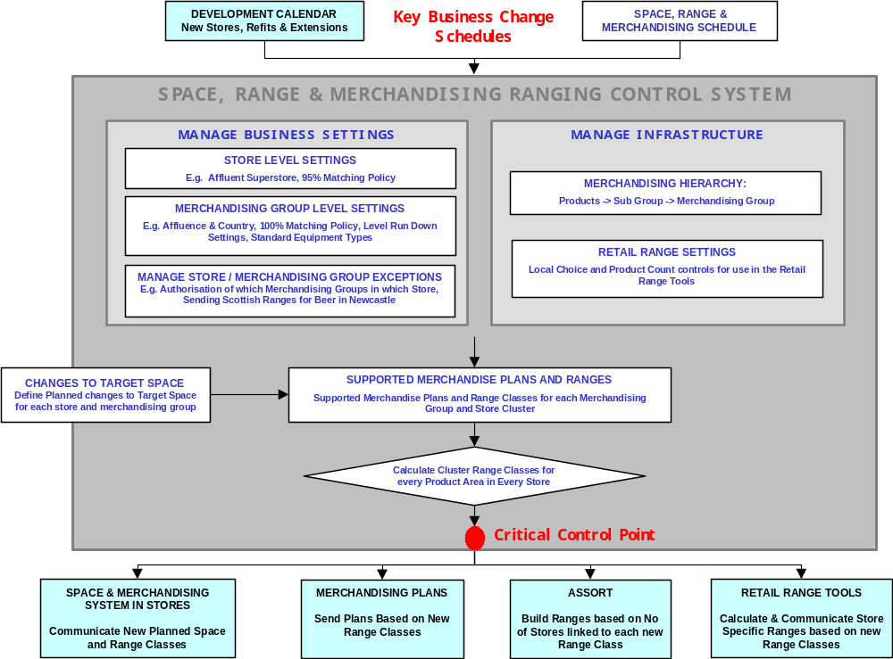

In the next section the function of each of the main applications within the Ranging Controls system is briefly described.

The Ranging Controls system will be configured on a common platform to support all Space, Range and Merchandising business processes.

Application Overview

Space, Range and Merchandise Schedule – This application will support the set up and maintenance of scheduled events. It will also be the control point for sending approved data to other systems

Merchandising Group Maintenance – This application will support central maintenance of all merchandising group data.

Pre-Ranging – This application will support the set up and maintenance of characteristics used in ranging merchandising groups. It then associates these characteristics to groups of stores (known as clusters) which are then used in ranging activities

Declaring Planned Space Changes – This application will mainly support the process to upload and make visible all multiple future dated planned space recommendations for any merchandising group and store combination

Supported Merchandise Plans– This application will facilitate the creation and maintenance of the current and future relationship between range class and space, while providing visibility of the relationships.

Controlling Cluster Range Classes – This application will calculate the range class for each store by merchandising group and provide reporting on the impact of any changes to the other areas of the system.

Reporting – A suite of new, standardised reports will be available to support the business processes. This application allows these reports to be requested.

Controls and Maintenance - This application will support the maintenance of all business parameters and potentially of user access to all areas of the Ranging Controls system.

Merchandising Group Maintenance Application Overview

Deliverables
In order to achieve the business objectives it will be necessary to:

- provide a series of new screens for the business users,
- have clearly defined and maintainable business rules,
- provide an application that manages the data,
- have and maintain one source of merchandising group data.

Benefits
The key benefits that this project will deliver are:

- The provision of a more user-friendly system for the business to use
- One business process to be used for all merchandising groups
- Improved visibility of merchandising group data in the centre
- The ability to future date the launch of merchandising groups and the
supplementary to parent merchandising group links.

Assumptions
This replacement system has been designed based on the following assumptions:

- that the planset information that currently makes up the other 4 characters of a planogram name will be maintained through ProSpace. For example the plan D2DGMAA, for Merchandising Group D2D, stands for:
- Range Class ‘G’,
- Equipment Type ‘M’,
- Cluster (formerly Region Code) ‘A’ and
- Planogram Sequence ‘A’

- that the redevelopment of the process to link merchandising groups to sub-groups now resides with CRST team, in the CW Futures system.

Scope
In scope are:

- All merchandising groups currently supported within PCX.
- Express merchandising groups.

Out of scope are:

- This development will facilitate, but not deliver the decommissioning of PCX.
- Any feeds of merchandising group data to downstream systems, other than the MH system.
- Linking merchandising groups to sub-groups.
- ROI.

The “AS IS” System
Merchandising groups are a way of grouping similar products for merchandising purposes. They are used across all space, range and merchandising systems to identify and manage groups of products. This application enables the business to create, manage and delete merchandising groups at the corporate level.

In the As-Is process, the Merchandiser advises the Space Insight team when a new merchandising group is required or an amendment has to be made. The basic merchandising group data is entered into the PCX Masterstore system by Space Insight and then supplemented with additional data by the Merchandising team. Once a week the full range of merchandising groups is uploaded to the mainframe for use across various Supply Chain and Commercial systems. A key task performed by Commercial is to link the merchandising group to a sub-group. The sub-group will have products linked with it. This task is outside of the scope of this application but is shown in the diagram below for completeness.

Process Overview
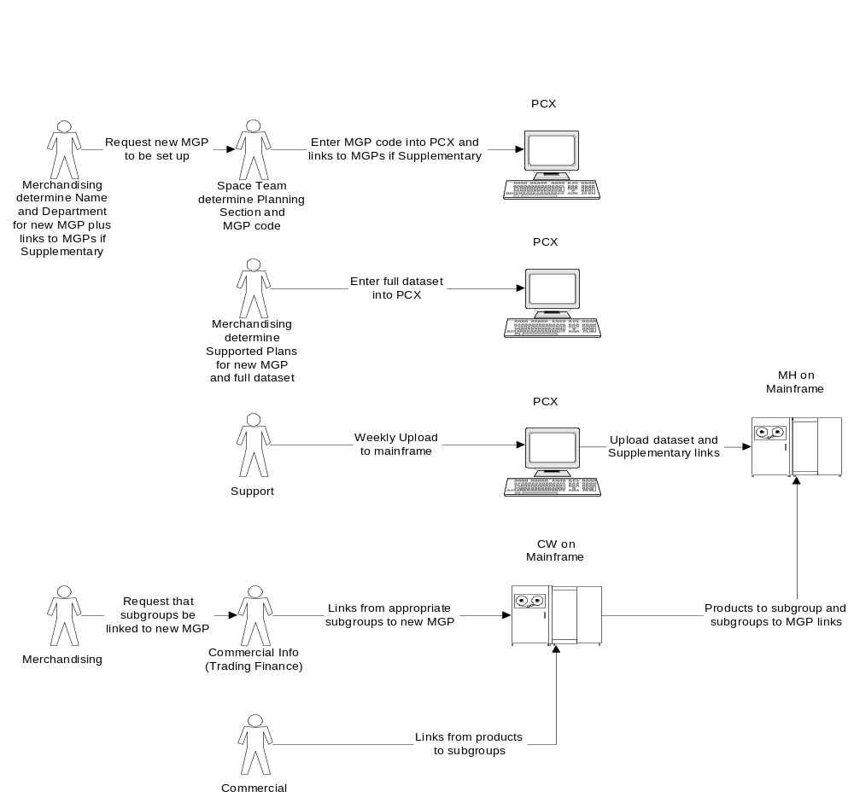

Process Description
There are three basic activities that may take place – the creation, amendment or deletion of a merchandising group and its attributes.

Create a New Merchandising Group
If the Merchandisers determine that a new merchandising group is required (possibly because new products don’t fit into an existing group), they ask Space Insight to create a new merchandising group based on the information they provide. The information provided will be the department code and to which parent merchandising groups it should be linked, if it is a supplementary merchandising group.

Space Insight creates the full 3 digit merchandising group code in Masterstore using the department code provided and selecting an appropriate section code. (The supplementary merchandising section codes, 6, 7 & 8, have no inherent meaning, but the aim is to use the lowest section code available).

If the new merchandising group is a supplementary (with a section code of 6, 7 or 8) or an Express merchandising group (section code of 9) it will need to be linked to at least 2 parent merchandising groups. The parents may only be selected from merchandising groups in the same department that do not already have a supplementary linked to them.

Once Space Insight have added the new merchandising group to Masterstore the Merchandising team add extra data that become the 4th, 5th & 6th digits of the Planogram code (the planset data). These codes relate to:

the Range Class (e.g. ‘I’)
the Equipment Type it will sit on (e.g. ‘H’ – High Level Ambient)
the Region Code (e.g. ‘D’ – Extra stores)

They also maintain other merchandising group attributes, such as temperature regime, worthing factors and minimum footage.

A weekly job uploads two files containing the standard merchandising group and supplementary groups data to the mainframe.

The uploaded information is used by the Store Layout Planners to establish what are the latest merchandising groups before creating further store plans.

Amend a Merchandising Group
If necessary a department or section description may be amended by Space Insight, at Merchandising’s request. But at the group level (the 3rd digit of a merchandising group) the description cannot be amended. To do this a new merchandising group would have to be created and the appropriate description attached. It is not possible to amend the code at any level, only the description.

Other merchandising group attributes (such as indicators) may also be amended by selecting an alternative from the options offered in the drop down boxes.

Space Insight is also responsible for changing supplementary to parent merchandising group links. This may mean de-linking a supplementary from one parent and linking it to another.

Delete a Merchandising Group

Space Insight may delete merchandising groups, providing all supplementary merchandising groups and sub-groups have been detached from the merchandising group.

Issues with the Current Process
The problems currently experienced can be broken into three categories:

Technical Issues:

- The PCX Masterstore system is inflexible and not user friendly,

- It will not run under Windows XP and the Simpler Desktop.

Support Issues:

- There is no support contract with A C Neilsens, the supplier of PCX,

- There is extremely limited knowledge within Tesco to support the software.

Business Issues:

- It regards Express merchandising groups, those with section code of ‘9’, as supplementary merchandising groups. This necessitates the creation of at least two dummy parent merchandising groups, which is wasteful use of valid merchandising group codes.

- The business is already supporting the planset data in another tool (ProSpace), so the existing process is not always followed. Consequently some of the data is becoming out of date and this is passed on to other business areas (Store Layouts).

Current Architecture
Masterstore, the system through which the merchandising group hierarchy is maintained, is part of the PCXpress software supplied by AC Neilsens. The software provides distributed applications across a number of servers with data extracts being passed to and from the mainframe.

The diagram below attempts to describe the system architecture.

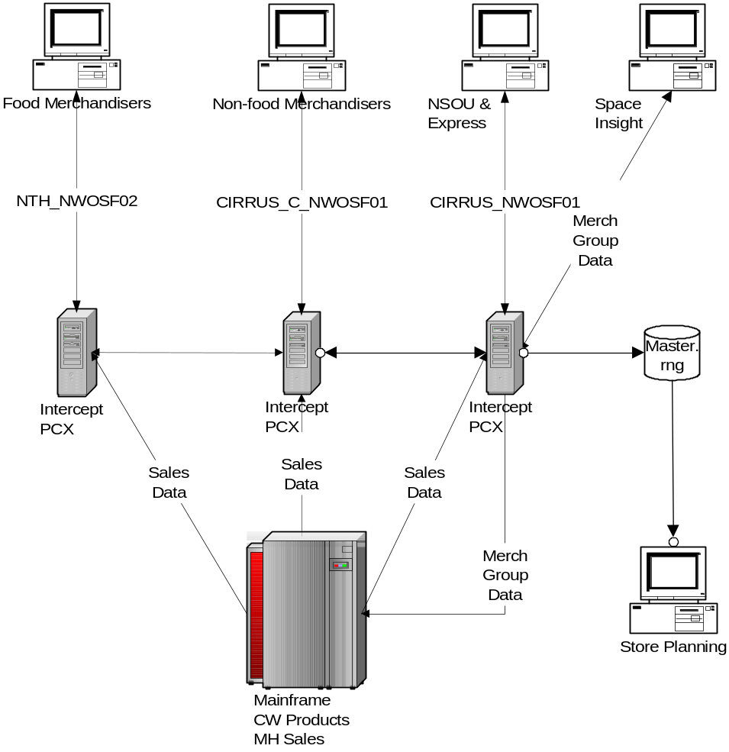

The “TO BE” System
Under the new system the Merchandiser will advise the Ranging Controls team when a new merchandising group is required or an amendment has to be made. The basic merchandising group data is entered into the new Merchandising Group Maintenance application by the Ranging Controls team. The Merchandising team no longer supplements this with additional data as that data is now maintained within ProSpace.

Whereas the full range of merchandising groups was previously uploaded to the MH system on the mainframe on a weekly basis, it will now be uploaded daily. The extract will continue to contain only those merchandising groups that are valid and current.

A new extract, containing all of the merchandising group data, is created and passed through the integration layer to the ODS. This data, particularly the future dated data, will be utilised by other SRM applications.

The task of linking of merchandising groups to sub-groups remains with Commercial and outside of this application.

Process Overview
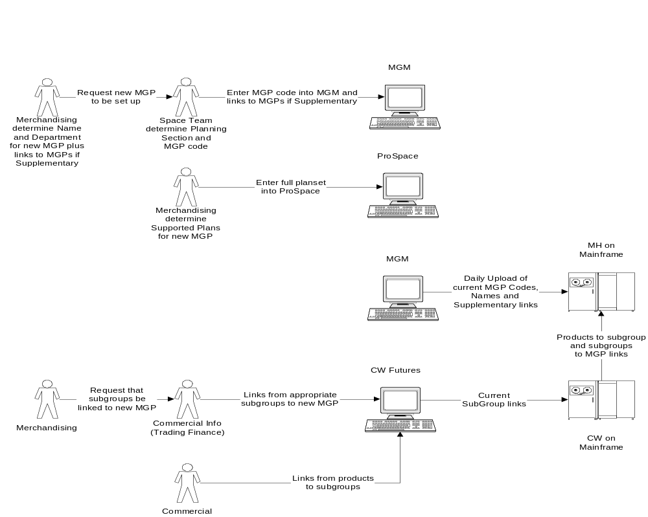

Process Description
The same three basic activities take place – the creation, amendment or deletion of a merchandising group – with the addition of being able to manage future dated supplementary links.

Create a New Merchandising Group
If the Merchandisers determine that a new merchandising group is required they will now ask the Ranging Controls team to create one based on the information they provide. The information provided will be the department code, an effective start date and to which parent merchandising groups it should be linked, if it is a supplementary merchandising group.

The Ranging Controls team creates the full 3 digit merchandising group code in the Merchandising Group Maintenance application using the department code provided and selecting a section code.

If the new merchandising group is a supplementary (with a section code of 6, 7 or 8) it will need to be linked to at least 2 parent merchandising groups. The parents may only be selected from merchandising groups in the same department that do not already have a supplementary linked to them. These links may also be created for a future date, if required.

Details of the current set of merchandising groups and the supplementary to parent links will be uploaded on a daily basis to the mainframe. All merchandising group information, particularly the future dated information, will be passed to the ODS, where it will be made available to other applications.

In future the Merchandising team will not supplement this data with anything extra and the Store Layouts Planners will obtain the data they require from a different source.

Amend a Merchandising Group
If necessary a department or section description may be amended by the Ranging Controls team, at Merchandising’s request. But the 3rd digit of an existing merchandising group cannot be amended. If a change is required a new merchandising group must be created and possibly the old one deleted.

The Ranging Controls team is also responsible for changing supplementary to parent merchandising group links. This may mean de-linking a supplementary from one parent and linking it to another.

Future dated links may not be amended. If a change is required the link should be deleted and the replacement created.

Delete a Merchandising Group
The deletion process remains the same as before, but performed by the Ranging Controls team.

Future Dated Supplementary Links

Adding
A future dated link between a supplementary and parent merchandising group may be created up to a year in advance of its implementation date. It is also possible to have multiple future dated links.

Example:

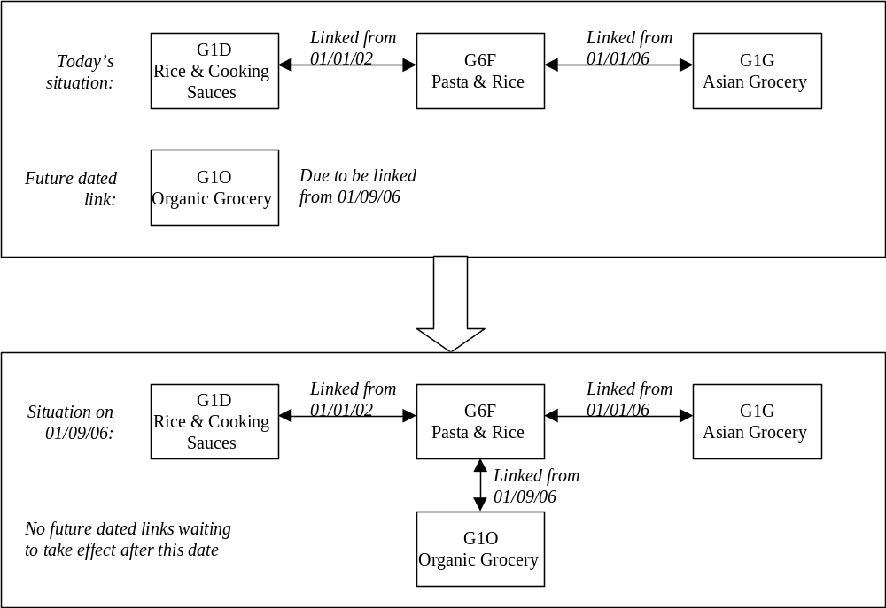

More supplementary links may be added if the start date falls after the date of the last future dated supplementary link.

If the business want to add a further link that does not add to the end of the list of existing links, but falls between links that have already been created, any links dated after the one being inserted will be automatically deleted. If these later links are still required they must be re-entered into the system.

Example:

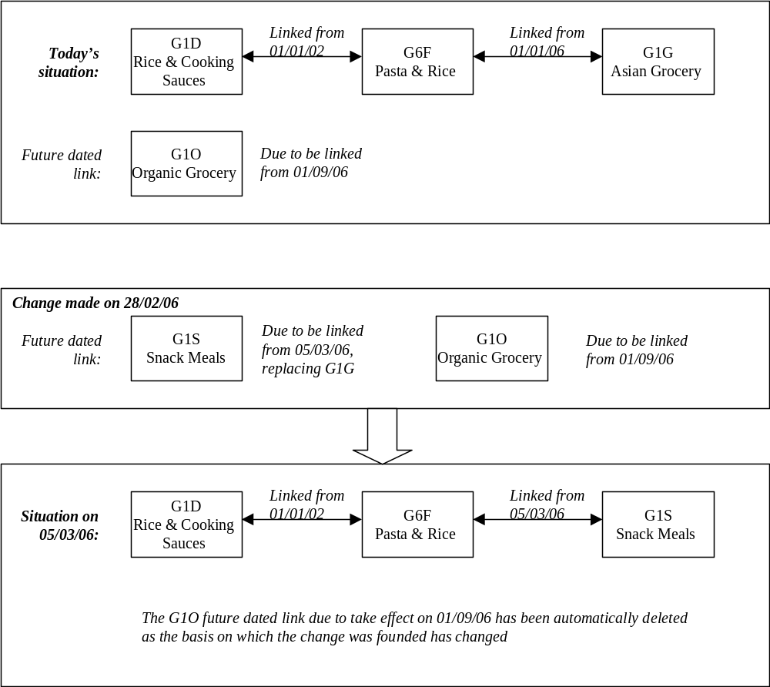

If the link to the G1O merchandising group is still required it has to be added back into the system.

Deleting
The Merchandising team may ask the Ranging Controls team to delete a future dated supplementary to parent merchandising group link. To delete a link it just has to be “de-selected”. However, the business rules will still apply and either a replacement link will need to be created or the other link removed before the transaction can be completed.

Business Rules
The following business rules are applicable:

- Future dating cannot be for more than 12 months in the future.

- Each linked supplementary merchandising group must have more than 1 parent

- The parents must be in the same department as the supplementary merchandising group

- The parents selected must not be linked to another supplementary merchandising group.

Roles and Responsibilities
The existing responsibilities will change with the introduction of the Merchandising Group Maintenance application. The tasks formerly performed by Space Insight will now be transferred to the Ranging Controls team.

Who | What | Why
Merchandising team | Request the creation of a new merchandising group | A new product grouping is required for merchandising purposes.
Ranging Controls team | Create new merchandising group in the system | To enable new product groupings to be ranged and allocated to stores
Merchandising team | Request a change of Department or Section name | To provide a better description of the types of products in this grouping
Ranging Controls team | Change the Department or Section name in the system | To provide visibility of the new description to all system users
Merchandising team | Request an amendment to a Merchandising Group | To reserve or release space for a merchandising group on a fixture within a store
Ranging Controls team | Enter requested amendment to a Merchandising Group into the system | Change the status of the Reserved Merchandising Group indicator to or from reserved
Merchandising team | Request a parent to supplementary merchandising group link | Until a supplementary merchandising group is linked to parents it is not live. The supplementary inherits the products and sub-group from the parent.
Ranging Controls team | Create a parent to supplementary merchandising group link in the system | To make the supplementary merchandising group active by linking it to a parent.
Merchandising team | Review impact of creating a new parent to supplementary merchandising group link | Existing future dated links may be automatically deleted as a result of creating a new link.
Ranging Controls team | Liaise with the Merchandising team if requested link cannot be made. | Seek further guidance on the changes to be made.
Merchandising team | Review changes that need to be made before the new link can be made. | Either several changes need to be made (de-linking from one MGP to another) or to select another parent.
Merchandising team | Request the deletion of a merchandising group. | To remove a redundant product grouping and to prevent its usage in future.
Ranging Controls team | Delete requested merchandising group from the system. | To prevent this particular product grouping from being ranged or allocated into a store in future.
Ranging Controls team | Liaise with the Merchandising team if requested deletion cannot be made. | Advise the Merchandising team of the remaining links preventing the MGP’s deletion.
Merchandising team | Review changes that need to be made before the MGP requested can be deleted. | If requested MGP to be deleted has any supplementary links, sub-group links or future dated supplementary links remaining they need to be removed before proceeding.
Merchandising team | Request the deletion of a parent to supplementary MGP link (including the linking of new parents, if appropriate). | To remove a redundant product grouping and to prevent its usage in future.
Ranging Controls team | Delete the requested parent to supplementary MGP link, creating a replacement, if required. | To prevent this particular product grouping from being ranged or allocated into a store in future.

Implications

Roles and Responsibilities
Today the Space Insight team has the responsibility for managing merchandising groups at the corporate level, based on information supplied to them by the Merchandising team.

In future the responsibility for creating, maintaining and deleting merchandising groups, supplementary links and any future dating, plus understanding the impact of any changes will lie with the Ranging Controls team, but still based on information supplied by the Merchandising team.

The Merchandising team will no longer need to maintain merchandising group attributes required by the Store Layouts team through PCX, only entering them into ProSpace (as at present) going forward.

Timings
As at present changes to merchandising groups, including their creation and deletion, may be made at any time.

Previously these changes would only be uploaded to the mainframe (and therefore made available to downstream systems) once a week. In future these changes will be uploaded and made available on a daily basis.

Impacts on Other Parts of the Ranging Controls System
The existing mainframe repository for merchandising group data is unable to hold dates against the merchandising groups or any links. There is no intention to change the mainframe repository or feed to it because no existing downstream system will require this information.

Consequently, applications that do require future dated information, such as Pre-Ranging, will need to obtain it from within the Ranging Controls system.

Impacts on Other Processes
As previously stated, the implementation of the MGM application will be another step forward in enabling the PCX software to be decommissioned.

The Property team are proceeding with other developments which will remove the Store Layouts team’s dependency on the data currently held in PCX.

System & Architectural Changes

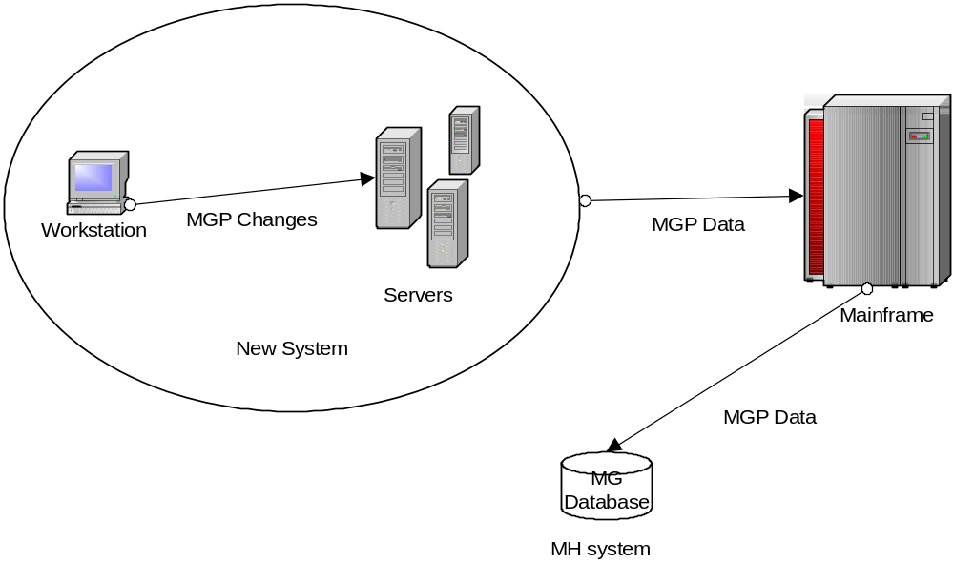

The merchandising group and supplementary links data will be maintained through a new application that forms a part of the new Ranging Controls system. Tables in the Ranging Controls system will house the data.

Each day an extract of the complete corporate level merchandising group structure will be created from the data on the new tables and transmitted to the MH mainframe system in the same file format as used at present, using the existing scheduled jobs.

Within the Ranging Controls system, any application requiring future dated merchandising group information should be able to access it directly from the tables, although the data will also be published to the ODS.

Requirements

Business System Requirements
The following business system and process requirements were identified as a means to providing the basic merchandising group maintenance functionality, along with providing additional functionality to support the Ranging Controls infrastructure required to support a merchandising event.

- A new application through which to manage merchandising groups
As the old software used to manage all aspects of merchandising group data cannot be supported going forward is inflexible in its structure, a new bespoke application is required. This will need to provide the facility to add and delete merchandising groups, as well as allowing some merchandising group attributes to be modified.

- Hierarchical rules governing the sequence in which merchandising group data can be entered
The process flow through the screens will control the sequence in which data may be entered, so supporting existing business processes and rules.

- Automated control of the removal of a merchandising group through the use of dates and rules
Using the future dating screen an Effective End Date for a merchandising group may be entered. This date reflects the date on which the merchandising group ceases to be effective in the Supply Chain and Commercial systems. On the nominated date all sub-groups will cease to be linked to the merchandising group (this is controlled through the Commercial systems, not the Ranging Controls system), making it ineffective even though may still be associated with stores. On reaching the Effective End Date the merchandising group will no longer be offered for linking to other merchandising groups or as an available option when creating a new merchandising group.

The removal of the merchandising group from the full corporate list may not be able to happen for some time as some reporting in downstream systems is based on merchandising groups and may also cover a broad period of time. Consequently the period of time (in weeks) that must elapse before a merchandising group can be removed from the full corporate list will be controlled by a parameter. On reaching the specified period of time the merchandising group should be automatically removed by the system.

- Process to link supplementary merchandising groups to parent merchandising groups
Facilities must be provided to enable links between parent and supplementary merchandising groups to be added and changed. The existing business rules that each merchandising group can only be linked to one supplementary, but each supplementary must have a minimum of two parents will remain. The process can be simplified by showing which (valid) parents are available to be linked and, if they’re not available, which supplementary they are currently linked to. This will enable the user to make a decision about whether they wish to rearrange some of the existing links to free up a suitable parent, if it is already used.

- Process to de-link supplementary merchandising groups from parent merchandising groups
Although there is no effective end date for a link it is possible to terminate the link between a supplementary and parent in one of two ways.

Firstly, the link can be manually removed, although the existing business rules will then come into force. However, if a supplementary merchandising group is left without any parent links it effectively becomes a redundant merchandising group.

If a future dated link has been set up then the redundant existing link becomes ineffective on reaching the event Launch Date (all future dated links will have to be associated with a merchandising event on the Merchandising Schedule). The redundant link can be automatically removed at this point in time.

- Current linkage rules can be maintained
The existing business rules state the number of parents and supplementaries that must be linked. These values should be parameterised and, in the longer term, available to be changed on-line.

- One process and repository for all merchandising groups
The new application should be able to support merchandising groups for Express stores, using exactly the same processes and tools. Currently Express stores are managed in a very different way.

System Requirements
The application for Merchandising Group Maintenance will reside on the new Ranging Controls system, as will the corporate level merchandising group data.

Interfaces
The only existing interface that will be replaced by this development will be the creation and transmission of the daily files containing details of the current merchandising hierarchy to be uploaded to the MH system on the mainframe.

A new interface to the ODS will enable all merchandising group and linking data (both current and future dated) to be published daily, where it can be accessed by other systems and applications.

System Parameters
All system parameters will ultimately be maintained via on-line screens within the Ranging Control system. These parameters cannot be maintained by every user of the system but only by those authorised to do so.

On-line Screens
There will be screens to create, manage and view merchandising groups, the merchandising group hierarchy and any links between parent and supplementary merchandising groups. Validation will ensure business rules are adhered to.

Wherever possible the screens will offer drop down selection menus, allowing the user to select an option from a list of valid values, rather than typing it in themselves. For example, when a merchandising department needs to be selected a list of valid merchandising departments will be provided from which one may be selected.

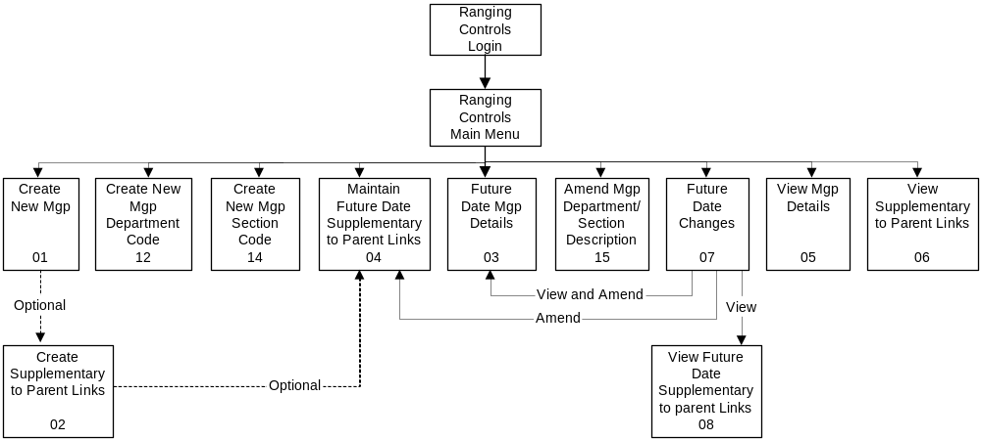
The diagram below shows the various screens (those highlighted) required for this development and how they can be reached, as not all screens may be accessed using the navigation toolbar.

Ease of Use
The system should have:

- The same look and feel as the other applications being developed as part of the Ranging Controls system

- The capability to include all types of merchandising groups (e.g. supplementaries and Express) where in scope of the project.

- The capability to future date both merchandising groups and supplementary links.

- The ability to create, update and delete all types of merchandising groups and supplementary links, where deemed appropriate by the business and in scope of the project.

- A logical flow where screen navigation is built in.

Reporting
It is assumed that some reporting may be required, but this has not yet been defined.

The intention is to leave this part of the development until the Reporting application is developed.

History Requirements
In accordance with the Non-Functional Requirements specified for all applications in the Ranging Controls system, any data required for reporting will be posted to the data warehouse, where it will be available for reporting purposes for 2 years.

The retention period of merchandising group data in the live environment after reaching any expiry date will be determined by the business defined rules, as previously stated.

Non-Functional Requirements
The non-functional requirements are described in a separate document which details service levels applicable to the whole of the Ranging Controls system.

Issues & Risks

Project Risk Log
Risk number | Risk & consequences | Likelihood | Impact
1 | There is a limited capacity of expert knowledge currently being shared across multiple projects | H | H
2 | Any change to roles and responsibilities following the signoff of the Business System Design could require re-work to the design, and hence increase costs and extend timelines. | M | H
3 | Transition plan from the As-Is process to the To-Be process is not yet identified, which may produce additional requirements for the project to enable rollout | M | H
4 | Aggressive timelines for delivery increase the probability of process or system design error | M | H
5 | All Ranging Control projects are interdependent in terms of system design and business process. Changes or delays to the delivery of any one project will impact on the delivery of all projects. | M | M
6 | Projects using a new technology which is unproven in Tesco. This may result in delay or changes, or additional expenditure. | M | M
7 | The rollout of the Simpler Desktop tools to the business is imminent. The upgrade to Microsoft XP means that PCX will not be accessible via up-graded machines. | M | M

Project Issue Log
Issue number | Describe the issue and consequences | Impact
1 | All development teams are currently running at capacity and may not be able to take on new work in the necessary timescales | H
2 | Two systems/processes/critical paths will need to be maintained during the transition to the To-Be process | H
3 | Day to day operational issues and other existing projects impact this project’s activities and milestones | M
4 | Some preparatory work will need to be done before moving merchandising groups into the new system. For example, considering how to migrate the data, bearing in mind that not all relationships (e.g. the Express merchandising group links to “dummy” parents) are to be carried forward into the new system. | M

SYSTEM DESIGN

High Level Design
The Merchandising Group Maintenance application comprises of a set of screens to allow the user to Add, Amend, View or Delete the component parts of all merchandising groups and the links between parent and supplementary merchandising groups. The managed data will be uploaded to the mainframe on a daily basis, so sustaining the corporate feed that currently exists. If other applications within the Ranging Controls system or related RSM systems require either corporate level merchandising group data or future dated data they will be able to obtain it directly from the database.

The MGM application is accessed via an option on the Ranging Controls system main menu. This menu also has a maintenance option, which will take the user to another application where the business rules and parameters used within MGM may be maintained. When the MGM application is entered the ‘View Merchandising Group Links’ screen is always the first screen presented to the user.

The left-hand pane of each screen contains a navigation bar that allows access to Creating a new merchandising group, department or section, Future Date a merchandising group or supplementary links or Update a department or section code. There is also an option that allows Enquiries into merchandising group details, supplementary links or future dated changes. There are also buttons that allow the user to either return directly to the (Ranging Controls) Main Menu or logoff the entire system, not just out of the MGM application.

From within the MGM application the user must complete any creation or maintenance task that is started, otherwise the data entered will not be captured after validation.

Create a New Merchandising Group (MGM01, MGM02, MGM04)

Purpose
The Ranging Controls team must enter all new merchandising groups into the MGM application so that there is a complete list of all merchandising groups currently used within the RSM, Commercial and Supply Chain systems in a single place. Until a merchandising group exists in this central repository it cannot be used or referenced by any other system.

Screen Flow

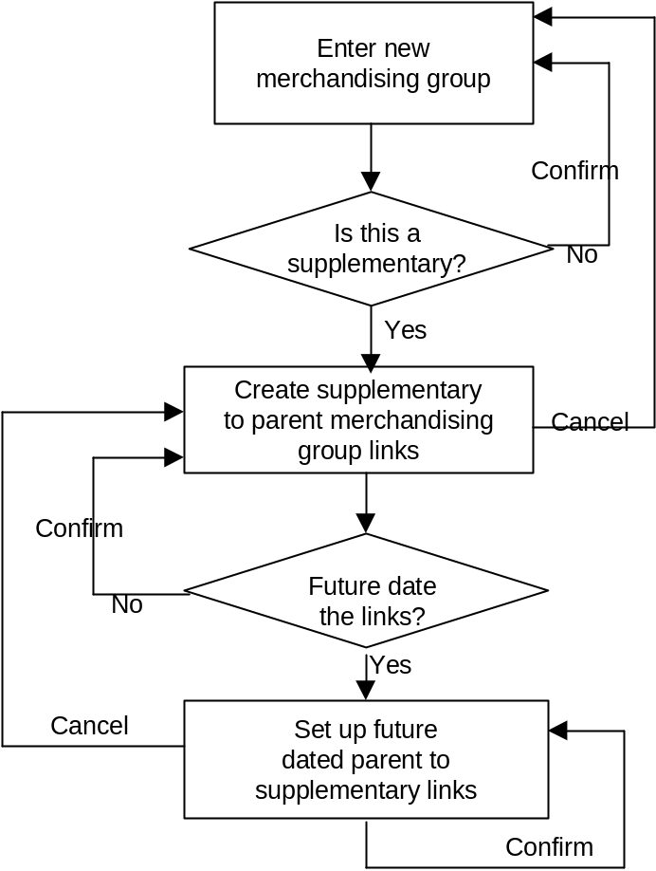

Process Flow
To create a new merchandising group the user must select the ‘Create a new Merchandising Group’ option from the navigation toolbar.

Using the details provided by the Merchandising team they will, in sequence, select a department from the drop down box, followed by a section and then finally select one of the available merchandising group codes offered. The user must now enter a description and short name for the new merchandising group. If the new merchandising group is to have reserved space then the default indicator should be changed to ‘yes’. Part of the validation process on hitting ‘confirm’ is to check whether the new merchandising group is a supplementary. If it is the user is automatically passed through to the ‘Create Supplementary to Parent Links’ screen. Otherwise they are advised that the transaction is complete and left on the screen, ready to navigate to wherever they wish to go next.

On being passed through to the ‘Create Supplementary to Parent Links’ screen the new merchandising group code and description are carried forward. Here the user must create new supplementary to parent links by either selecting from those currently available or by choosing the future dated option. If selecting from those currently available the user will be returned to the ‘Create a New Merchandising Group’ screen when he confirms the new links.

If opting to set up future dated links the user is passed to the ‘Future Dated Supplementary to Parent Links’ screen. The details of the new supplementary merchandising group are carried forward. By selecting a merchandising event to which to be linked the user is then offered a choice of parent merchandising groups to select from. As some may already be linked there is the option to de-link them, making them available for selection. This would mean that the supplementary recently de-linked now needs to be re-linked to a different parent merchandising group before the transaction can be completed, as shown in the example below. In order for P6F to be able to link to P4G in the future it has to be de-linked from P6G. This leaves a parental gap for P6G that must be filled before the transaction can be completed.

 | Parent MGP |  |  | Supp.  MGP
 | P4A | Ambient Salad
 | P5B | Roots |  | P6F | Combined Ambient Veg
As at | P5G | Potatoes
01/03/06
 | P4G | Ambient Salad
 | P5D | Luxury Veg/  Cut Herbs |  | P6G | Organics
 | P4A | Ambient Salad
 | P4G | Ambient Salad |  | P6F
 | P5B | Roots |  | P6F | Combined
As at | P5G | Potatoes |  |  | Ambient Veg
01/06/06
 | P4G | Ambient Salad
 | ? |  |  | P6G | Organics
 | P5D | Luxury Veg/  Cut Herbs

When all the links have been established and confirmed, the user is returned to the ‘Create Supplementary to Parent Links’ screen, ready to navigate to wherever they wish to go next.

If cancel is chosen at any point the user is returned to the previous screen without any data being captured.

Create a New Department or Section Code (MGM12, MGM14)

Purpose
These activities enable the user to set up a new merchandising department or a new merchandising section according to the Merchandising team’s requirement.

In both instances the new merchandising grouping will be required to support a way of grouping products that doesn’t fit neatly into the existing merchandising framework. For example, the existing merchandising department of ‘Seasonal’ currently covers all events such as Christmas and Easter. If the business decides that Christmas should have its own department then a new department will need to be set up. In creating a new merchandising department it follows that both merchandising sections and groups will need to be created underneath it to support the new product groupings. So new sections for Christmas sweets and Christmas decorations may be required, along with many others.

It is also possible that a new merchandising section may be required within an existing merchandising department.

Screen Flow

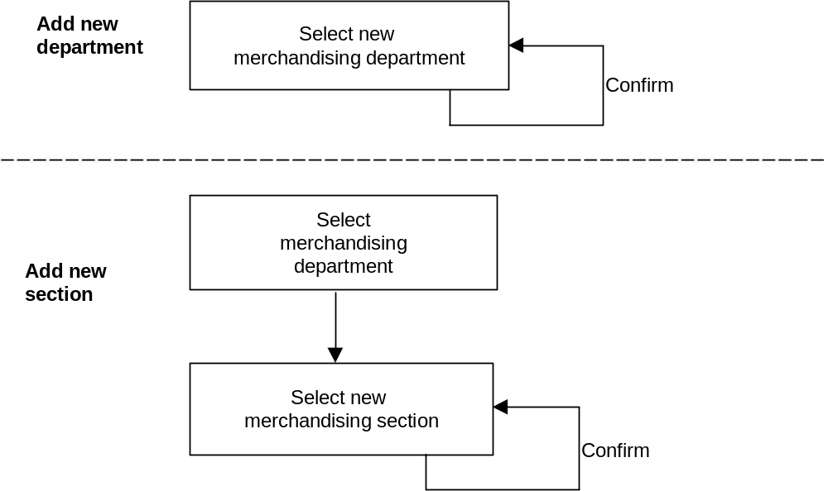

Process Flow
To create a new merchandising department or section the user selects either ‘Create New Merchandising Department’ or ‘Create New Merchandising Section’ screen. This will take them to the ‘Create New Merchandising Group’ screen, where only the merchandising department and, if appropriate, section fields will be available to them.

Using the details provided by the Merchandising team they will choose the required merchandising department and/or section from the drop down box and enter the new name provided. On confirmation they will remain on the screen until a new activity is selected from the navigation toolbar.

Amend Merchandising Department or Section Name (MGM15)

Purpose
This activity allows the business to change the name of merchandising departments and sections, when considered necessary. These types of changes would not occur very frequently.

Screen Flow

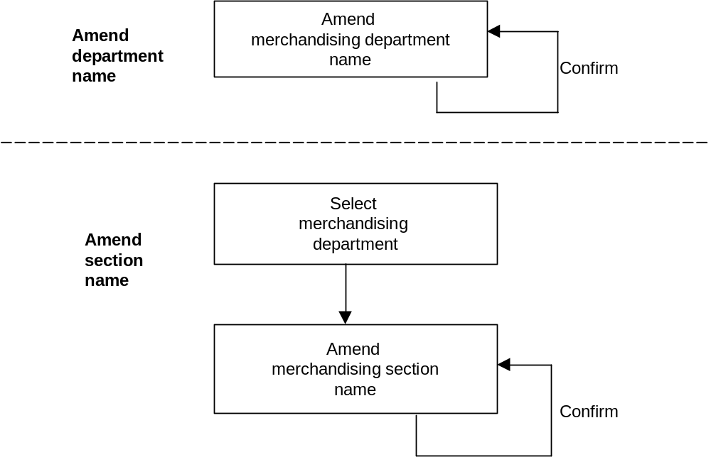

Process Flow
To amend the name of a merchandising department or section the user ‘Amend Department/Section Name screen. .

Using the details provided by the Merchandising team they will choose the required merchandising department and/or section from the drop down box and enter the new name provided. On confirmation they will remain on the screen until a new activity is selected from the navigation toolbar.

Future Dated Merchandising Group Details (MGM03)

Purpose
This activity allows the details of an existing merchandising group to be amended for a future dated merchandising event. The merchandising event with which it is associated must already exist on the Schedule. This enables users with Write access or Superuser access to enter changes into the system as soon as they know them, rather than having to remember to make the change nearer the event date. Details of the required change will be supplied to the Ranging Controls team by the Merchandising team. This screen can also be viewed by users with Read access.

Screen Flow

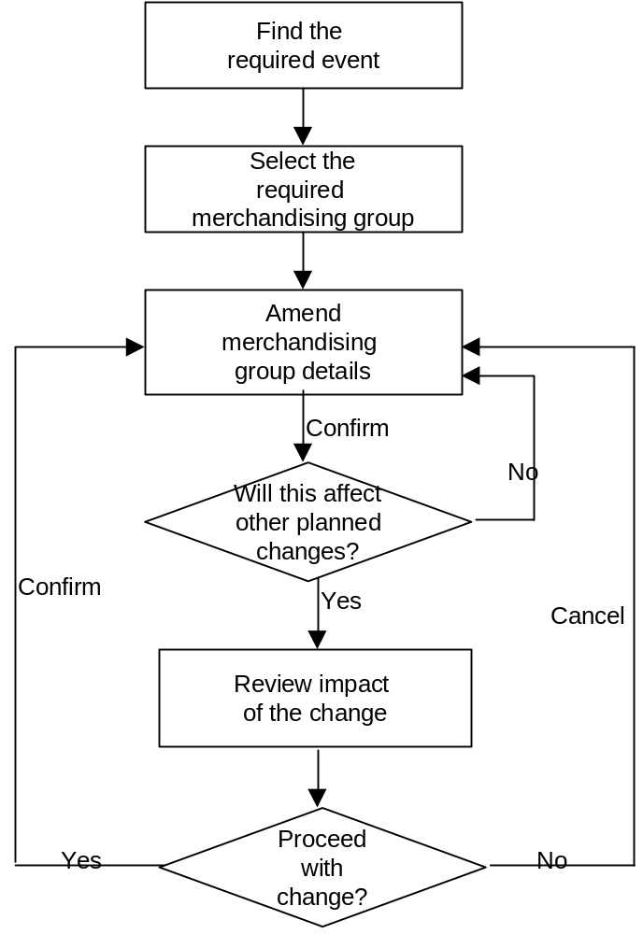

Process Flow
Using the data provided by the Merchandising team the Ranging Controls team may find either the required event or merchandising group first, using the drop down boxes. Any associated data available will automatically populate the remainder of the screen. The fields that may be altered are: Delete this Merchandising Group as part of this Event (Y or N), and Reserved Merchandising Group (Y or N) .

When the change is confirmed the system will check to see if there are any later future dated merchandising group changes, including parent to supplementary merchandising group links involving the merchandising group being changed. If none are found the change is completed and the user left on the screen to select their next activity from the navigation toolbar.

If further future dated merchandising group events are found the user will be automatically passed to the ‘Future Dated Changes’ screen, where they will be able to review a list of all further changes to be applied to this merchandising group. Where supplementary links are shown it will be possible to drill down further to see the details of the links by placing the cursor on the required change and then selecting the Details buton, which will take the user to the ‘Future Dated Supplementary to Parent Links’ screen. Similarly it will be possible to see further information on each Merchandising Group change through the ‘Future Date Merchandising Group Details’ screen.

If the user opts to continue with the change they are passed back to the ‘Future Date Merchandising Group Details’ screen, where they can select their next activity from the navigation toolbar. The system will automatically delete all of these subsequent changes, advising the user to now revisit the Schedule to reflect these changes by removing the merchandising group from the later events, if appropriate.

If the user opts to cancel the change they will be passed back to the ‘Future Date Merchandising Group Details’ screen, where they can select their next activity from the navigation toolbar.

Future Dated Supplementary to Parent Links (MGM04)

Purpose
At times it may be necessary to change the parent merchandising group that a supplementary is linked to. Either the parent may be required for linking to another supplementary or a more appropriate parent may have been established, and so the link needs to be moved. Details of the required change will be supplied to the Ranging Controls team by the Merchandising team.

Screen Flow

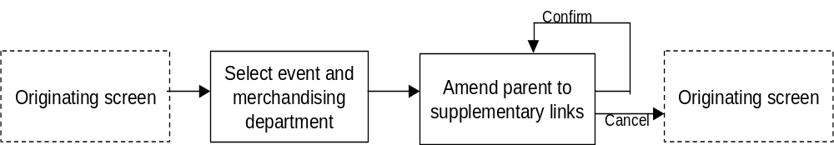

Process Flow
This particular screen can be accessed in 4 different ways:
- From the Future Dated Changes screen
- From the View Future Dated Changes screen
- From the Create Supplementary to Parent Links screen
- From the navigation menu

If coming from the navigation menu, neither the merchandising group nor event is selected. If coming from the ‘Create Supplementary to Parent Links’ screen the merchandising group will be carried forward, but an event then has to be selected from the drop down menu. If coming from the ‘Future Dated Changes’ screen or the View Future Dated Supplementary to Parent links screen, both the merchandising group and event will be carried forward.

The links shown in the Current Links box are those that will be in effect on the date of the selected event and not the current date. Working from this base it is possible to link a parent merchandising group to an available supplementary by highlighting the required parent in the Current Links box and then selecting an available supplementary from the Available Supplementary Merchandising Group box, providing no business rules are contravened.

If the required parent merchandising group is already linked to another supplementary it is possible to de-link it by reversing the above process, and then creating the required link.

On confirmation the user remains on the ‘Future Date Supplementary to Parent Merchandising Group Links’ screen, where they can select their next activity from the navigation toolbar.

No later dated future dated links will be deleted as a result of this activity because the links are assumed to remain in force until either they are manually removed or other future dated links supersede them.

If the user opts to cancel the change they will be passed back to the appropriate originating screen, where they can select their next activity from the navigation toolbar.

View Group Details (MGM05)

Purpose
This screen enables all application users to have visibility of any merchandising group in existence and its attributes.

Screen Flow

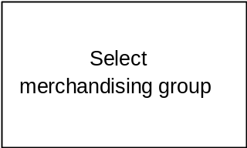

Process Flow
Anyone with access to the Merchandising Group Maintenance application will be able to select the ‘View Merchandising Group Details’ option from the navigation toolbar.

On gaining access to the screen the only options available are to either select a merchandising group from the drop down box, which will result in the details about that merchandising group being displayed, or to select another option from the navigation toolbar.

View Supplementary to Parent Links (MGM06)

Purpose
This screen enables all application users to have visibility of the parent to supplementary merchandising group links that currently exist. To view future dated links they will need to use the ‘View Future Dated Changes’ screen.

Screen Flow
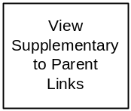

Process Flow
Anyone with access to the Merchandising Group Maintenance application will be able to select the ‘Supplementary to Parent Links’ option from the navigation toolbar.

On gaining access to the screen the user selects a merchandising group from the drop down box, which will result in the details of any existing links, if any, for the selected merchandising group being displayed. The only other possible action is to select another option from the navigation toolbar.

Future Dated Changes (MGM07)

Purpose
This screen enables all application users to have visibility of any parent to supplementary links that may exist in the future. For users with Write or Superuser access, it also allows the possibility of making changes to these future dated links. To view any current links they will need to use the ‘View Supplementary to Parent Links’ screen (MGM06).

Screen Flow

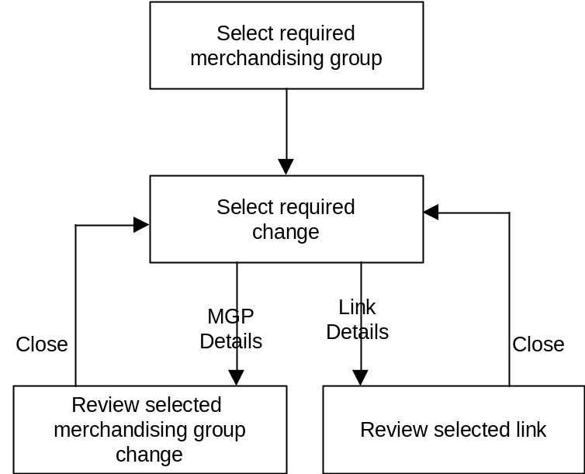

Process Flow
Anyone with access to the Merchandising Group Maintenance application will be able to access the ‘Future Dated Changes’ screen, where they will be able to review a list of all further changes to be applied to this merchandising group.

Where supplementary links are shown it will be possible to drill down further to see the details of the links by placing the cursor on the required change and then selecting the Details button, which will take the user to the ‘Future Dated Supplementary to Parent Links’ screen. In each instance closing the window will return the user to the previous screen until the ‘Future Dated Changes’ screen is reached, from where they may select another option from the navigation toolbar.

Screens
The following screens are required for this application:

Screen id | Screen title | BSD section
MGM01 | Create New Merchandising Group | 6.2.1
MGM02 | Create Supplementary to Parent Links | 6.2.2
MGM03 | Future Date Merchandising Group Details | 6.2.3
MGM04 | Maintain Future Date Supplementary to Parent Links | 6.2.4
MGM05 | View Merchandising Group Details | 6.2.8
MGM06 | View Supplementary to Parent Links | 6.2.9
MGM07 | Future Date Changes | 6.2.10
MGM08 | View Future Date Supplementary to Parent Links | 6.2.11
MGM12 | Create New Merchandising Department Code | 6.2.5
MGM14 | Create New Merchandising Section Code | 6.2.6
MGM15 | Amend Merchandising Department/Section Description | 6.2.7

MGM01.01 Create a New Merchandising Group
This screen is used to create a new merchandising group for a department and section that already exists.

Navigation

Create Supplementary to
Parent Merchandising
Group Links
- Create A New Merchandising Sup Merchandising Group Details Merchandising Group
- o Parent Link

Main Menu

Screen

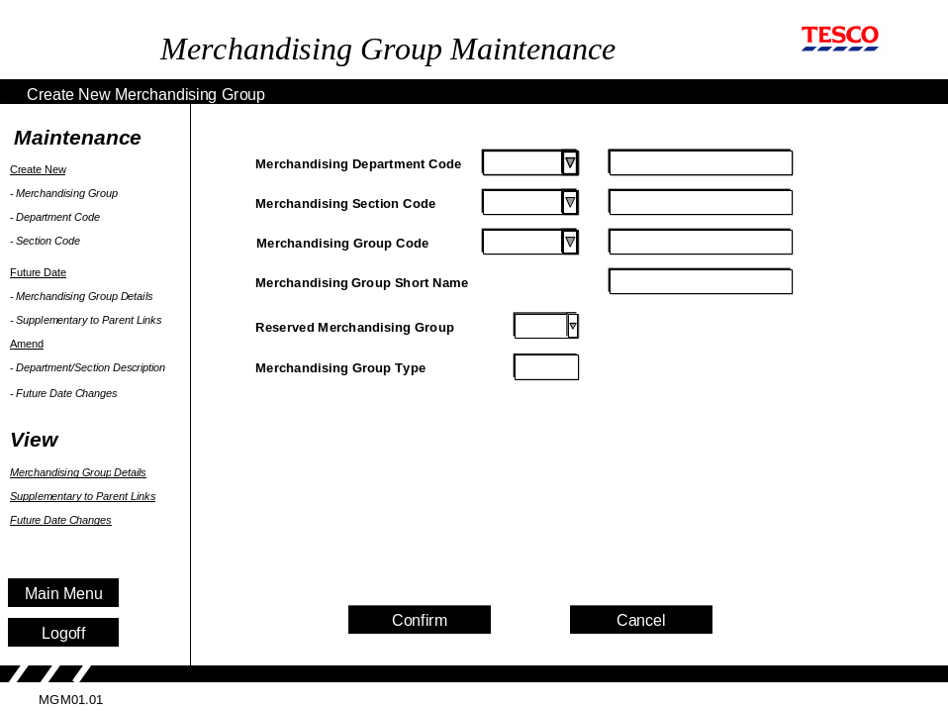

Process Flow
The first 3 boxes must be filled in the sequence that they are shown on the screen.

Using the drop down boxes provided the department and section can be selected and their descriptions displayed as they are selected. Only existing departments and sections within departments will be shown.

Then the next available single character group code for the department/section combination selected will automatically be displayed. However, it is not compulsory to use this selection and a different one can be picked from the drop down list of available options. The user must now enter a new merchandising group name and short name.

New merchandising groups are effective immediately, i.e. they are written to the database and made available within MGM, and any other linked system, on the day they are created. This date is for use only by the system; it is not seen by the user.

The Reserved Merchandising Group has a default value of ‘No’, which can be changed using the drop down menu. This indicator controls whether a fixed amount of space will always be reserved for this merchandising group in any store that has this merchandising group attributed to it.

The Merchandising Group Type description is automatically filled based on the value entered in the Merchandising Section field. The meaning of the Section codes is described in section 2.2.1 of this document and should be used to determine the description required.

When the transaction is confirmed an initial check has to be made before any of the data is saved. If the Merchandising Section indicates that this is a supplementary merchandising group the user must be automatically passed to the ‘Create Supplementary to Parent Merchandising Links’ screen to set up the parent to supplementary merchandising group (see section 6.2.2). On return to this screen the transaction may be completed and the data saved.

If the merchandising group being created is not a supplementary the data may be captured straight away on confirmation.

The user is left on this screen to select their next activity from the navigation toolbar on the left-hand side of the screen.

Field Descriptions
Field | Description | Comments
Merchandising Department Code | A unique code to identify the merchandising department | A 1 character alphabetic code  When the screen is first displayed, focus is on this field.
 | The description of the merchandising department  e.g. G = Hard Grocery | At present the MH system only displays 31 characters, so some descriptions are truncated
Merchandising Section Code | A numeric code that identifies the merchandising section | A 1 digit numeric code  1 – 5 indicate a main group  6 – 8 indicate a supplementary,  9 indicates an Express merchandising group.
 | The description of the two character merchandising section  e.g. G1 = Savoury Foods | At present the MH system only displays 31 characters
Merchandising Group Code | An alphabetic code that identifies the merchandising group | A 1 character/alpha code. On its own it has no meaning
 | The description of the full character merchandising group  e.g. G1G = Asian Groceries | At present the MH system only displays 31 characters
Merchandising Group Short Name | The description shown on the merchandising plans | Maximum of 12 characters
Reserved Merch. Group | A merchandising group that may be merchandised in a reserved space. An example is seasonal products | Mandatory Y/N via a drop down menu.  Default is N.
Merchandising Group Type | Describing whether the merchandising group is a main/parent group, a supplementary or an Express merchandising group | The entry is determined by the application from the section code.

Security Access
Access to this screen = Write and Superuser

MGM02.01 Create Supplementary to Parent Links
If a new supplementary merchandising group has been created the user is automatically passed to this screen to create the parent to supplementary links. Without these links the new supplementary merchandising group cannot become live.

As a reminder, the rules around creating and removing links for non-Express supplementary merchandising groups are:

- Each supplementary merchandising group must have more than 1 parent (unless being de-linked in readiness for deletion)

- The parents must be in the same department as the supplementary merchandising group

- The parents selected must not be linked to another supplementary merchandising group.

Navigation
This screen cannot be accessed directly from the menu bar. It can only be reached by adding a new supplementary merchandising group.
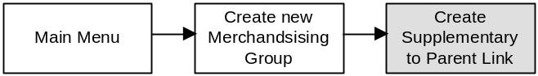

Screen
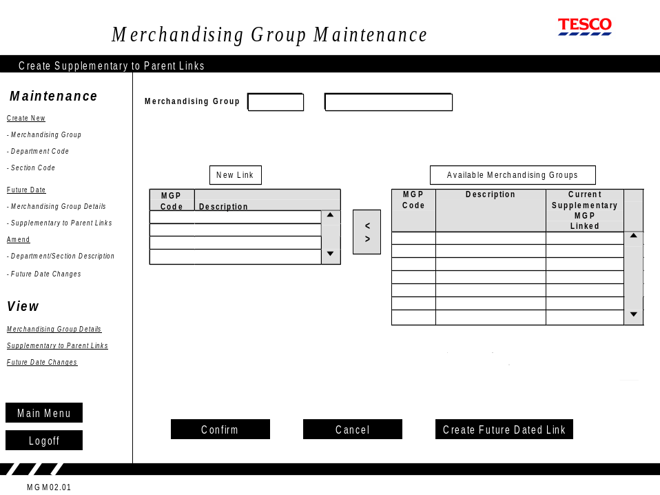

Process Flow

The merchandising group code that needs to be linked and its description are carried forward from the previous screen.

Initially the New Link box will be empty. A complete list of all possible merchandising groups that could be linked (from within the same merchandising department) are shown in ascending order in the Available Merchandising Groups table. Those not available for attachment (because they are already linked to other supplementary merchandising groups) are still shown, but made unavailable for selection. The final column shows the supplementary merchandising group to which the parent merchandising group is attached, if any.

Note that supplementary merchandising groups and Express merchandising groups are not included in the MGP Code column of the Available Merchandising Groups table because a supplementary cannot be linked to another supplementary.

To select a parent merchandising group and create the new link a parent is selected from the Available Merchandising Group table and moved to the New Link table, using the arrows in the middle to copy it across. The parent merchandising group selected isn’t removed from the Available table, but it can no longer be selected from the Available table.

If a previous selection is to be deselected it can be removed using the appropriate arrow button. The entry in the Available Merchandising Groups table is removed and the entry on the Available table becomes available for selection again.

If the user wishes to link to a merchandising group that is already linked to another supplementary they can do so by pressing the ‘Create Future Dated Link’ button.. Section 6.2.4 details the processing of future dated supplementary to parent merchandising group links. On completion of the future dated linking the user is automatically returned to this screen.

On confirmation the data entered is validated. If fewer than two parent merchandising groups are linked to the supplementary an advisory message should be displayed, advising that two merchandising group links are required.

On successful validation all data is captured and the user is automatically returned to the ‘Create a New Merchandising Group’ screen where they can select their next activity from the navigation toolbar on the left-hand side of the screen.

Field Descriptions
Field | Description | Comments
Merchandising Group | The three character merchandising group code (e.g. G1G) for the new merchandising group created on the previous screen | This is carried forward from the previous screen. It cannot be amended
Description | The description of the new merchandising group | This is also carried forward from the previous screen
MGP Code | The codes of the merchandising groups in the same merchandising department (e.g. G – Hard Grocery) that are potential candidates to be parents to the new supplementary merchandising group | These are automatically displayed by the application and cannot be edited.  Those already attached to supplementaries are displayed but cannot be selected for linking  When the screen is first displayed, focus is on the first MGP code in the list of Available Merchandising Groups.
Description | The description of the merchandising groups that are potential candidates to be parents | These are automatically displayed by the application and cannot be edited.
Current Supplementary MGP Linked | The three character merchandising group code of any supplementary merchandising group already linked to the potential parent merchandising groups listed | These are automatically displayed by the application and cannot be edited.

Security Access
Access to this screen = Write and Superuser

MGM03.01 Future Date Merchandising Group Details

Using this screen it is possible for users with Write access and Superuser access to amend the details of a merchandising group in advance of when the change is required. For users with Read only access, it is possible to view the screen.

This screen can be accessed from the navigation menu and the Future Dated Changes screen.

Navigation

Future Date Merchandising Group Details
- Details

- k Department Description
- s
- de

Main Menu
Future DateChanges

Screen

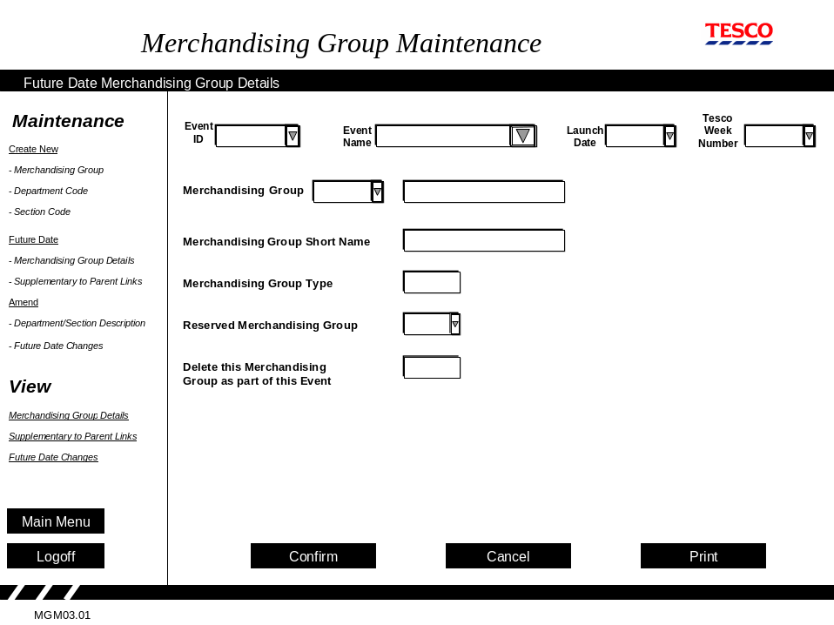

Process Flow
If this screen is accessed from the navigation menu by a user with write access or superuser access, the user selects the event with which to associate this merchandising group change. Selecting from any of the event drop-downs (Event ID, Event Name, Launch Date and Tesco Week Number) will automatically populate the remaining Event fields. Alternatively they can manually enter an Event ID. If an unrecognised Event ID is entered issue a message advising that it is unrecognised. The user may enter another manually or select an ID from the drop down menu.

The Merchandising Group drop down menu will now display all the merchandising groups associated with the selected event.

Alternatively, the user may either enter a merchandising group into the Merchandising Group field or select one from the drop down menu. Having chosen one, all events that have the selected merchandising group associated with it will now be available through a drop down menu on the Event fields. Once an event has been selected from the Event ID or Event Name fields the remaining event attributes are automatically completed for the selected event.

If this screen has been accessed from the Future Dated Changes screen, the screen will display details of the previously selected merchandising group, Event ID, Name and launch date the change has been associated with.

To delete a Merchandising Group as part of this Event, the user sets the “Delete this Merchandising Group as part of this Event” field to Y. On the Event Launch Date, the flagged Merchandising Group will be removed from the MGM system. However, it will be retained in the database for a further 2 weeks, after which it will be deleted.

Users with Write access (or Superuser access) can change the following settings:
- Reserved Merchandising Group (Y or N)
- Delete this Mgp as part of the event (Y or N)

Users with Read-only access can view (and print) the screen details only.

On confirmation that the change has been completed, the system will check whether any other future dated changes exist that have a later date than the one being created here. If any exist the user will be automatically passed to the ‘Future Dated Changes’ screen to review the impact before any data is captured. On return to the ‘Future Date Merchandising Group Details’ screen the user should be asked if they still wish to proceed.

If the user confirms that they wish to proceed, the new data is captured and any changes with a later Event date than the one being created are automatically deleted.

If the change is cancelled (Cancel button), nothing is captured. The user remains on the ‘Future Dated Merchandising Group Details’ screen where they can select their next activity from the navigation toolbar on the left-hand side of the screen.

Selecting the Print button prints a copy of the screen.

Field Descriptions

The screen is the same as the Create New Merchandising Group screen, with the exception of the Event and Event Date related screens, so the common fields are not described here.

Field | Description | Comments
Event ID | A unique identifier for each event held on the Space, Range and Merchandising Schedule application | If accessed from the navigation menu, an event ID may be selected from the drop down menu or manually entered. Optional.  If accessed from the Future Dated Changes screen, field selection is carried over.
Event Name | A name to describe the event held on the Space, Range and Merchandising Schedule application | As for Event ID.
Launch Date | The launch date for an Event held on the Space, Range and Merchandising Schedule. | Automatically displayed by the application and cannot be edited
Tesco Week number | The number of the Tesco week during which the event goes live in Store. It is calculated in the Space, Range and Merchandising Schedule application, based on the launch date. | Automatically displayed by the application and cannot be edited
Delete this Merchandising Group as part of this Event | Toggle box to flag this merchandising groups for deletion as part of this Event. | Options = Yes or No  Default value = No.

When the screen is first displayed, focus is on the Reserved Merchandising Group field.

Security Access
Access to this screen = All users

MGM04.01 Maintain Future Date Supplementary to Parent Links
Through this screen the Ranging Controls team can set up a link between a supplementary and parent merchandising group for an Event in the future on the Space, Range and Merchandising Schedule. These links are still subject to the business rules previously outlined in section 6.2.2.

Navigation
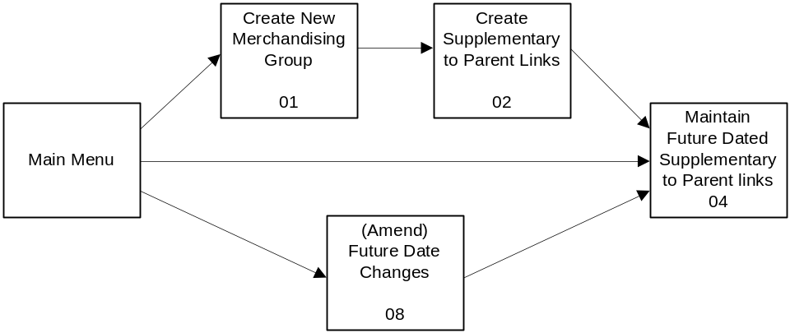
This screen can be accessed through three different paths.

Screen

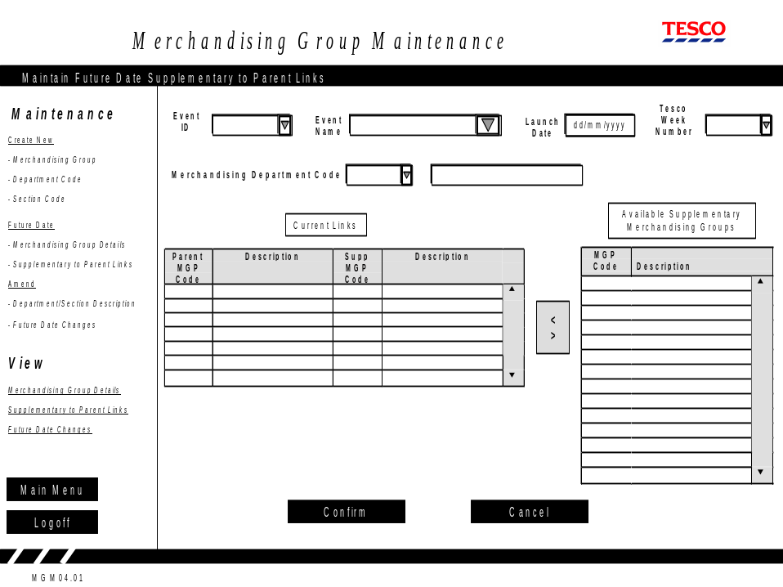

Process Flow
- If selected from the Navigation Toolbar

On entering this option from the navigation toolbar, all fields on the screen will be blank and focus will be on the Event Id field. Using the drop down menus for either the Event ID or Event Name, the user may select or enter the appropriate event (as advised by the Merchandising team) to link the change to. Once an event has been selected then Event ID, Event Name, Launch Date and Tesco Week Number fields will be populated with the relevant details for that Event.

Potentially the list of available Events may be several hundred thereby making it difficult for the user to select the right one. Although it is mandatory to select either an Event ID or an Event name, optionally entering the Launch Date and or Tesco Week Number will help to filter down the possible options.

Having selected an Event, the user must now select or enter a merchandising department from the drop down menu. On selection the merchandising department name will be automatically populated. This, in turn, will result in all the links for all supplementary merchandising groups within the selected department that are expected to be in force at the time of the chosen Event will appear in the Current Links box. Each link can be selected using the mouse.

The lists should be displayed in descending order (where A is the first letter and 1 is the highest number). All parent merchandising groups that are expected to exist in the merchandising department selected will be displayed, even if they have no supplementary links. If they are linked to a supplementary then this will show in the next column of the Current Links table. Displaying all parent merchandising groups gives the user the opportunity to make alterations to existing links by de-linking the supplementary from the parent and then linking the parent to a different supplementary.

To create a new parent to supplementary merchandising group link select the required parent merchandising group to be linked on the current link table (providing it is available) by clicking on it. Then select the relevant supplementary merchandising group from the Available Supplementary Merchandising group table and use the arrows between the two tables to move the supplementary merchandising group across. As a supplementary must be linked to at least two parents each of the parents may be individually selected before the Confirm button is pressed.

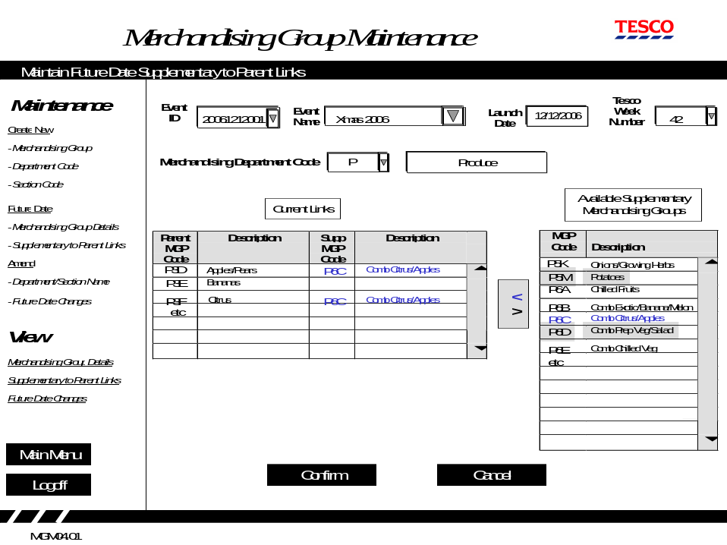
In the example shown below, the aim is to link the Supplementary P6C, Combined Citrus/Apples, to two new parents, P3D, Apples/Pears and P3F, Citrus, just for the Christmas 2006 event. Although it wouldn’t be desirable to have linked the supplementary to P3E, the bananas merchandising group, it would not have been possible, anyway, as it is already linked to a different supplementary merchandising group. The only way that link might have been possible would have been to de-link P6B and then link the new supplementary, remembering that the supplementary that has been de-linked may now need to be linked to a new parent if it has been left with just one.

To de-link an existing link the user should highlight the appropriate parent on the ‘Current Links’ table and then by using the arrows between the two tables remove the Current Link.

On confirmation all changes are checked to ensure that all supplementary merchandising groups still have a minimum of two parent merchandising groups attached. If any do not have two parents an advisory message should be issued and the changes not captured until the anomaly is resolved.

If the change is cancelled, nothing is captured. If the validation checks are successful the data is captured. In either case the user remains on the ‘Future Date Supplementary to Parent Links’ screen where they can select their next activity from the navigation toolbar on the left-hand side of the screen.

- If linked from ‘Create Supplementary to Parent Links’ screen (MGM02)

If the user has selected the Create Future Dated Link button on the Create Supplementary to Parent Links screen they are automatically passed to this screen.

The new supplementary merchandising group that has just been created will have been added to the Available Supplementary Merchandising Group Table. The merchandising department will be populated based on the merchandising group department letter along with its description. When the screen is first displayed, focus is on the Event ID field. The user then selects an Event to link the change to, as per the previous section. As soon as an Event is entered the tables will be populated.

The process for linking supplementary to parent merchandising groups will be the same from this point, until the transaction has been completed. On completion the user will be returned to the ‘Create Supplementary to Parent Links’ screen.

- If linked from the (Amend) ‘Future Dated Changes’ screen (MGM07)

If the user has selected Future Date Changes from the Amend menu and drilled down on a Supplementary Link item on the Future Dated Changes screen, and they have Write access or Superuser access, they will be passed automatically to this screen.

If a user with read-only access selects Future Date Changes from the Amend menu, access is denied.

The data in the Event ID, Name, Launch date and Tesco week numbers fields are carried forward to this screen and the department code populated based on the merchandising group links being viewed. All of these fields are non-editable for this operation.

When the screen is first displayed, focus is on the first Parent MGP Code field in the list of Current Links.

The Current Links and Available Supplementary Merchandising Group tables will be populated based on the department code, as before, and can be amended, as with the two previous processes.

The process for linking supplementary to parent merchandising groups will be the same from this point, until the transaction has been completed. On completion the user will be returned to the ‘View Future Dated Supplementary Links’ screen.

Exception Handling
Regardless of the access path taken to reach this screen, the exception handling is the same in each case:

If no Event has been selected from the drop down menu or a valid one manually entered, then a message advising that data is missing should be displayed.

Similarly, if an unrecognised Event ID or Name is entered, an advisory message stating that the Event ID or Name is unrecognised should be displayed. The user may then once again enter an Event ID or Name or select one from the drop down menu.

If only one parent merchandising group has been selected an advisory message should be displayed, stating that at least 2 parents are required. It would be acceptable for there to be no links with parent merchandising groups if the supplementary is no longer used or to be used, but the user would need to confirm that this is the intention.

Field Descriptions
The screen contains very similar fields as those displayed on the Create Supplementary to Parent Links screen, as described in section 6.2.2, with exception to the Event related fields and the Merchandising Department selection field, so are not shown here.

Field | Description | Comments
Event ID | A unique identifier for each event held on the Space, Range and Merchandising Schedule application | Select an event ID from the drop down menu or enter an event ID. Optional.
Event Name | A name to describe the event held on the Space, Range and Merchandising Schedule application | Select an event from the drop down menu or enter an event name. Optional.
Launch Date | The launch date for an Event held on the Space, Range and Merchandising Schedule. | Automatically displayed by the application and cannot be edited.
Tesco Week Number | Tesco week number event goes live in Store calculated in the Space, Range and Merchandising Schedule based on the launch date. | Automatically displayed by the application and cannot be edited.
Merchandising Dept Code | The merchandising department code (e.g. G – Hard Grocery) | This will allow multiple links to be set up in the same department at the same time.
 | The description of the merchandising department | Displayed automatically by the application when a department has been selected

Security Access
Access to this screen = Write and Superuser

MGM12.01 Create New Merchandising Department Code
This screen is similar to the ‘Create A New Merchandising Group Screen’.

Only users with Superuser authority may access this screen.

Navigation
Create A New Merchandising Department

Main Menu

Screen
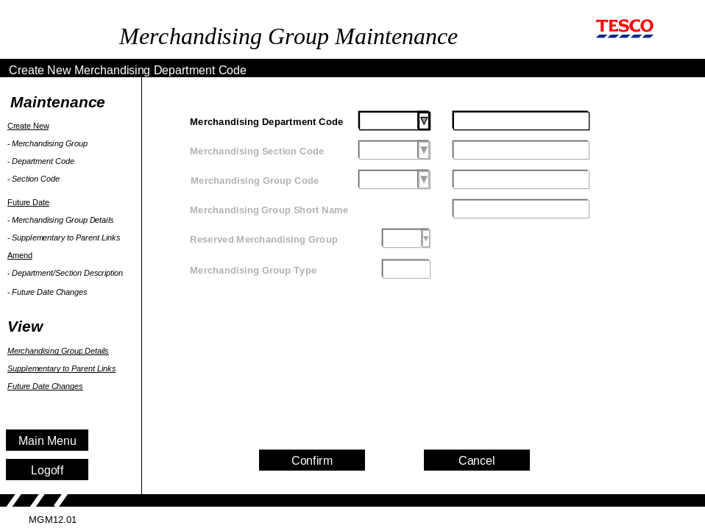

Process Flow
When the Create a New Department Code option is selected from the navigation toolbar the user is taken to the ‘Create a New Merchandising Department’ screen, which has a similar format as the ‘Create a New Merchandising Group’ screen. Only the Department Description field may have data manually entered into it. The new Department Code may be selected from the drop down list of available codes. Available Department Codes may be identified because they have no description. When the screen is first displayed, focus is on the Merchandising Department Group field.

All other fields on this screen will remain blank and unavailable for selection or editing at all times.

On confirmation the new code and description are captured. The user can select their next activity from the navigation toolbar on the left-hand side of the screen.

Field Descriptions
Field | Description | Comments
Merchandising Dept Code | The merchandising department code | One alpha character A to Z
Description | The description of the merchandising department | Up to a maximum of 31 characters

Security Access
Access to this screen = Superuser

MGM 14.01 Create New Merchandising Section Code
A new merchandising section within a department can be created using a screen similar to the ‘Create A New Merchandising Section’ screen. The section code fields will be editable. However as a section code on its own means little, the department code fields will also be selectable..

Only users with superuser authority may access this screen.

Navigation
Create A New Merchandising Section

Main Menu

Screen

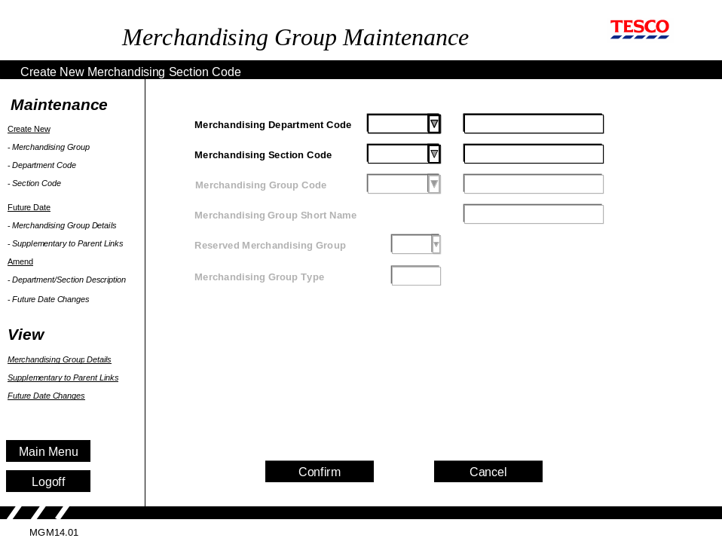

Process Flow
When the Create a New Section Code option is selected from the navigation toolbar the user is taken to the ‘Create a New Merchandising Section’ screen, which is similar in format as the ‘Create a New Merchandising Group’ screen.

As the Section Code and Description only have meaning in the context of a Merchandising Department, the user must select a department from the drop down menu list first. When the screen is first displayed, focus is on the Merchandising Department Code field. Only those Departments that are already assigned should be displayed. These can be identified as they have a description. When a Department Code has been selected the Description should be automatically displayed but unavailable for editing.

Only the Section Description field may have data manually entered into it. The new Section Code may be selected from the drop down list of available codes. Available Section Codes may be identified because they have no description.

All other fields on this screen will remain blank and unavailable for selection or editing at all times.

On confirmation the new code and description are captured. The user can select their next activity from the navigation toolbar on the left-hand side of the screen.

Field Descriptions
Field | Description | Comments
Merchandising Dept Code | The merchandising department code (e.g. G) | Must be one alpha character
Description | The description of the merchandising department  e.g. G = Hard Grocery | At present the MH system only displays 31 characters, so some descriptions are truncated
Merchandising Section Code | A numeric code that identifies the merchandising section | A 1 digit numeric code  1 – 5 indicate a main group  6 – 8 indicate a supplementary,  9 indicates an Express merchandising group.
Description | The description of the two character merchandising section  e.g. G1 = Savoury Foods | At present the MH system only displays 31 characters

Security Access
Access to this screen = Superuser

MGM15.01 Amend Merchandising Department/Section Description

The description of an existing merchandising department and section can be amended using a screen that is based on the ‘Create a New Merchandising Group’ screen.

Only those users with Superuser authority may access this screen.

Navigation
Amend
Merchandising
Department/Section Description

Main Menu

Screen

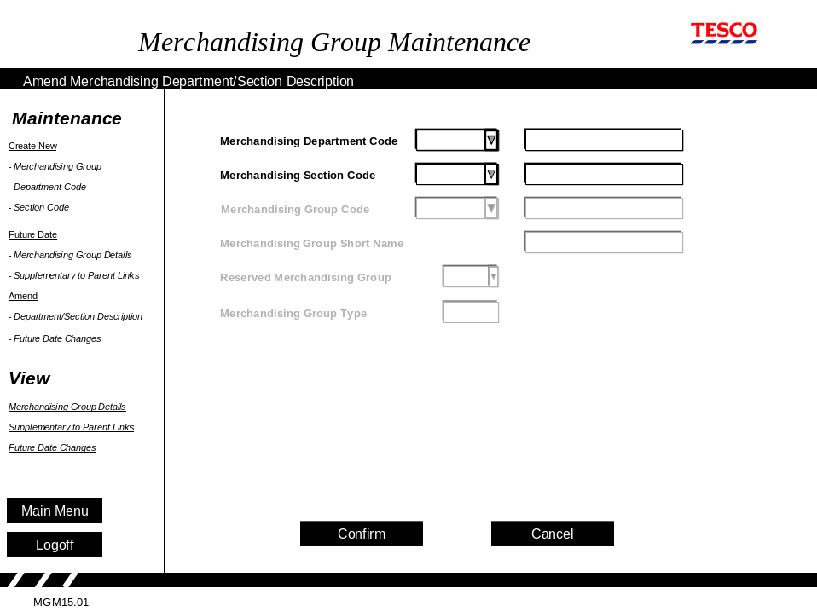
Process Flow
When the Amend Department/Section Description option is selected from the navigation toolbar the user is taken to the ‘Amend Merchandising Department/Section Description’ screen, which has the same format as the ‘Create a New Merchandising Group’ screen. When the screen is first displayed, focus is on the Merchandising Department Code description field.

To change a Department description, the user selects an existing department from the drop down list of departments. Existing departments are identified because they have a description. The current Department Description for the department selected is displayed as an editable field.

As the Section Code and Description only have meaning in the context of a Merchandising Department, if the section code description is to be changed, a department code must be selected from the drop down menu list first. Only those Departments that are already assigned should be displayed. These can be identified as they have a description. When a Department Code has been selected the Description should be automatically displayed

The Section Code may be selected from the drop down list of existing codes. Existing Section Codes may be identified because they have a description.

Only the Department and Section Description fields may be edited. All other fields on this screen will remain blank and unavailable for selection or editing at all times.

On confirmation the amended details are captured. The user can select their next activity from the navigation toolbar on the left-hand side of the screen.

Field Descriptions

Field | Description | Comments
Merchandising Department Code | The merchandising department code (e.g. G) | Select a department from the drop down menu.
Description | The description of the merchandising department | Displayed automatically by the application when a department is selected.  Editable field
Merchandising Section Code | The merchandising section code (e.g. 1) | Select a section from the drop down menu.
Description | The description of the merchandising section | Displayed automatically by the application when a section has been selected  Editable field

Security Access
Access to this screen = Superuser

MGM05.01 View Merchandising Group Details
This screen is the entry screen for the Merchandising Group Maintenance system. From the Main Menu selection screen this is the one that a user would be automatically passed to when selecting the Merchandising Group Maintenance option.

This screen allows all users of the MGM application to view the current status of a single merchandising group.

Navigation
View Merchandising Group Details

Screen

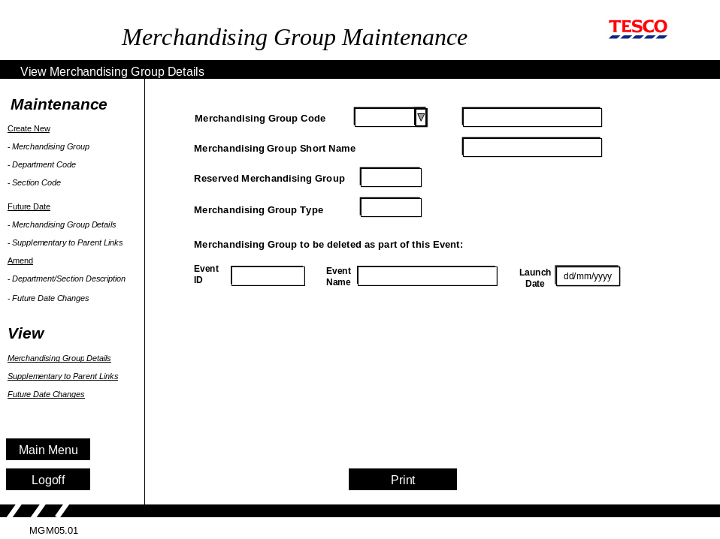

Process Flow
The entire content of this screen is available as view only. When the screen is first displayed, focus is on the Print button (as the only selectable item on the screen).

Using the drop down box, or by typing in an existing merchandising group code is selected. This will automatically populate the merchandising group name.

The Reserved Merchandising Group and Merchandising Group Type attributes are displayed.

If the selected Merchandising Groups has been flagged for deletion as part of an Event, the Event ID, Event Name and event Launch Date are displayed.

A paper copy of the screen is available when the Print button is selected.

On completion the user may choose another activity from the navigation toolbar.

Field Descriptions

The fields on the screen are exactly the same as those described for the Create A New Merchandising Group screen, in section 6.2.1.

Security Access
Access to this screen = All users

MGM06.01View Supplementary to Parent Links

This screen enables all users to see the current parent to supplementary links for a single merchandising group. It is accessible only from the navigation menu.

Navigation
View Merchandising Group Links

Main Menu

Screen

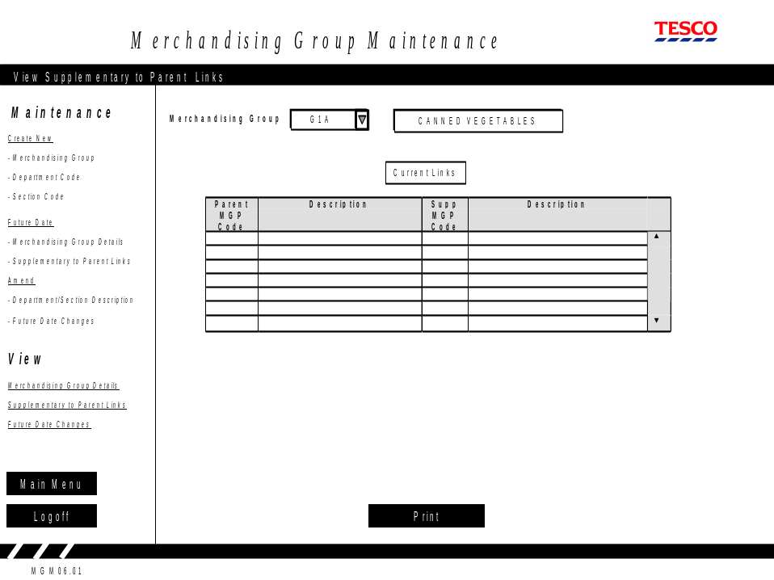

Process Flow
When the screen is first displayed, focus is on the Merchandising Group field. The user must select a merchandising group from the drop down box at the top of the screen or type one in. This will result in all of the current supplementary to parent merchandising group links and a description for the merchandising group being displayed.

A paper copy of the screen is available when the Print button is selected.

On completion the user may choose another activity from the navigation toolbar.

Field Descriptions

Field | Description | Comments
Merchandising Group | The merchandising group code (e.g. G1A) | Mandatory. May be manually entered or selected from the drop down menu.
Description | The description of the merchandising group
Parent MGP Code | The merchandising group code (e.g. G1A) | These are automatically displayed by the application and cannot be edited or entered
Description | The description of the merchandising group
Supplementary MGP Linked | The code of any supplementary merchandising group linked to the main merchandising group listed | The 3 character code  (e.g. G6A)
Description | The description of the supplementary merchandising group

Security Access
Access to this screen = All users

MGM07.01 Future Date Changes

Using this screen all users can search for merchandising groups that have any future dated changes associated with them and then, depending on their security access, either views the future dated changes, or edit them. This can be done either using the selection boxes at Department and Section level or by entering the full merchandising code across the three boxes if all three characters are known.

Navigation
View Future Dated Changes

Main Menu

Screen

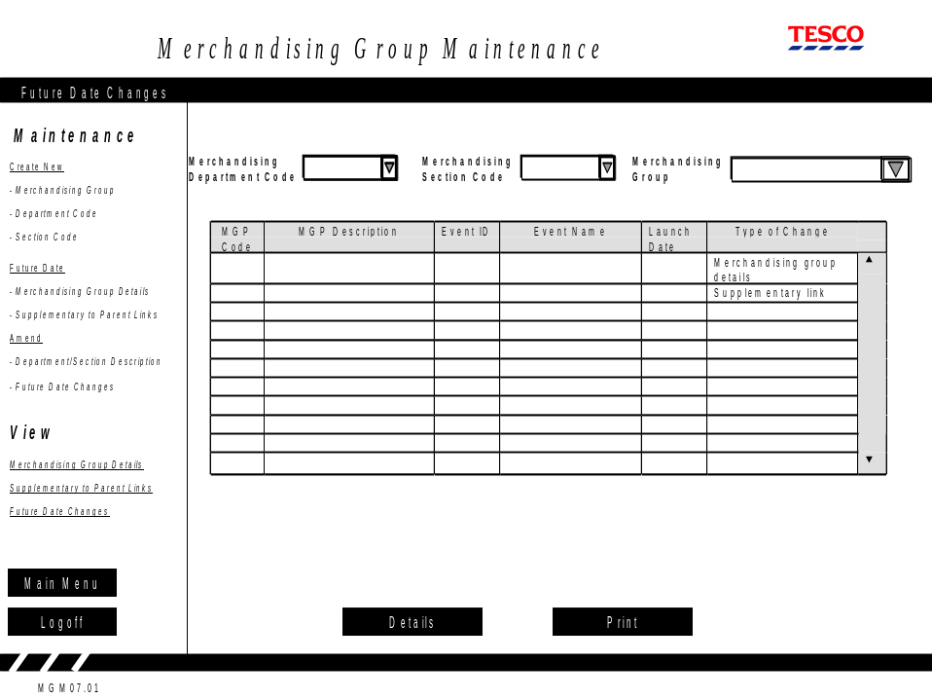

Process Flow
The entire screen can only be used in browse mode. None of the fields in the table are editable. The user can print this screen, or select a row in the table, press the Details button to see details of the change.

When the screen is first displayed, focus is on the Merchandising Department Code field. Using each of the drop down menus in turn (left to right) will limit the available options to existing departments, sections or groups in the subsequent menu, until a merchandising group is selected.

Choosing the Merchandising Section drop down menu without having selected a Merchandising Department is not a valid action and an advisory message should be displayed.

The user also has the option to type directly into the fields, if the codes are known. However, if an unrecognised Merchandising Department, Section or Group Code or incomplete Section or Group Code is entered (e.g. a section code without a department code) an advisory message should be issued.

Having selected a merchandising group the table will be populated with all occurrences of that merchandising group where a future dated change has been applied. The table will show the Merchandising Group Code and description, the Event ID, Event Name and launch date with which the change is associated and the type of change.

Once the table has been populated the user now has two options. They can either print the screen or view the lower level of detail for a Merchandising Group change. To view the lower level detail the user has to highlight the relevant Merchandising Group change they are interested in and the select the ‘Details’ button at the bottom of the screen. The type of change the user has selected (Merchandising Group Details or Supplementary Links) will then determine which screen the user is then passed to.

Alternatively the user may choose another activity from the navigation toolbar.

Field Descriptions
Field | Description | Comments
Merchandising Dept Code | A unique code to identify the merchandising department | A 1 character alphabetic code
The description of the merchandising department
e.g. G = Hard Grocery
Merchandising Section Code | A numeric code that identifies the merchandising section | A 1 digit numeric code  1 – 5 indicate a main group  6 – 8 indicate a supplementary,  9 indicates an Express merchandising group.
The description of the two character merchandising section
e.g. G1 = Savoury Foods
Merchandising Group Code | An alphabetic code that identifies the merchandising group | A 1 character/alpha code. On its own it has no meaning
The description of the full character merchandising group
e.g. G1G = Asian Groceries
Event ID | A unique identifier for each event held on the Space, Range and Merchandising Schedule application | Automatically displayed by the application and cannot be entered.
Event Name | A name to describe the event held on the Space, Range and Merchandising Schedule application | Automatically displayed by the application and cannot be entered.
Launch Date | The launch date for an Event held on the Space, Range and Merchandising Schedule. | Automatically displayed by the application and cannot be entered.
Type of Change | Details of which type of future dated change applies to MGP / Event i.e. MGP details or Supplementary link | Automatically displayed by the application and cannot be entered.

Security Access
Access to this screen = All users

MGM08.01 View Future Date Supplementary to Parent Links
It is not possible to reach this screen from the navigation toolbar. It is only accessible by navigating through the ‘Future Dated Changes’ screen when selected from the View – Future Date Changes menu option. All users with access to the Ranging Controls system may access this screen.

Having selected Supplementary Links change from the (View) ‘Future Dated Changes’ screen the user is passed to this screen. Here they may review the links set up for the future, seeing which supplementaries are tied to which parents and when.

Navigation

Main Menu
(View) Future Dated Changes
View Future Dated
Supplementary to Parent Links

Screen

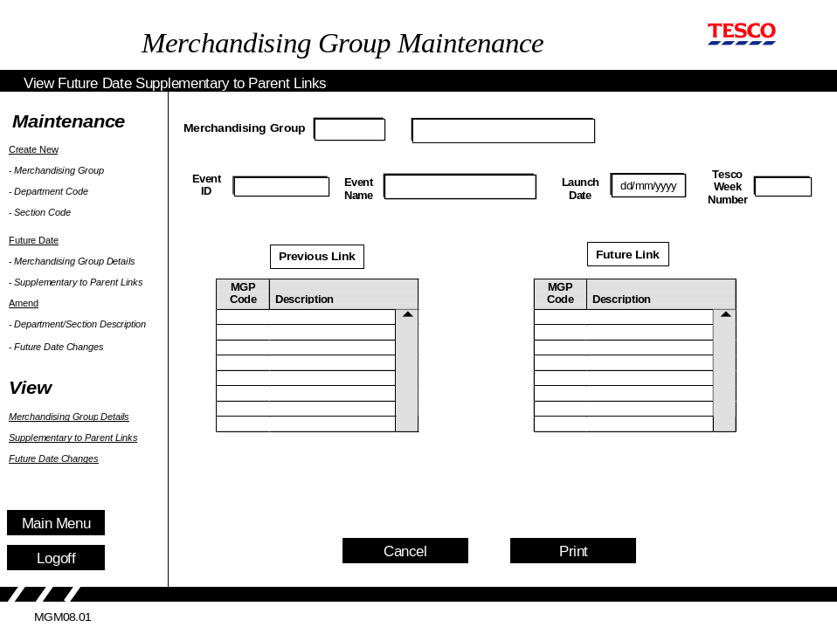

Process Flow
The user will have been passed to this screen having selected details of a future dated supplementary link change for a merchandising group. The screen will show the user the merchandising group they selected, the Event ID, Name and launch date the change has been associated with. They will also be shown 2 tables. One details the appropriate links that will be in force prior to the change being effective, while the other details what the links will be when the Event takes place.

It should be noted that the details in the previous link table may not reflect the actual links in place at the time of viewing this screen. This is because there may be several other future dated changes for the Merchandising group in place between the current date and the Event selected.

When the screen is first displayed, focus is on the Cancel button (the first selectable item on the screen). A paper copy of this screen is available when the Print button is selected.

On completion the user may choose another activity from the navigation toolbar.

These screens enable the user to select the appropriate merchandising group and date, before showing the links effective on that date.

The remainder of the Process Flow and Field Descriptions can be found in section 6.2.4, Set Up Future Dated Parent to Supplementary Merchandising Group Links.

Field Descriptions
Field | Description | Comments
Merchandising Group Code | An alphabetic code that identifies the merchandising group | Carried forward from previous screen.
 | The description of the merchandising group | Carried forward from previous screen.
Event ID | A unique identifier for each event held on the Space, Range and Merchandising Schedule application | Carried forward from previous screen.
Event Name | A name to describe the event held on the Space, Range and Merchandising Schedule application | Carried forward from previous screen.
Launch Date | The launch date for an Event held on the Schedule. | Carried forward from previous screen.
Tesco Week Number | Tesco week number event goes live in Store calculated in the Schedule based on the launch date. | Carried forward from previous screen.
Previous link Merchandising Group Code | An alphabetic code that identifies the merchandising group | The merchandising group(s) that were linked to the selected MGP prior to this change becoming effective.
Description | The description of the merchandising group
Future Link Merchandising Group Code | An alphabetic code that identifies the merchandising group | The merchandising group(s) that will be linked to the selected MGP once this change becomes effective.
Description | The description of the merchandising group

Security Access
Access to this screen = All users

Other Processes
This section describes processes outside this project that may be affected by the introduction of this project.

Inputs from Other Processes
This section describes data that this project needs which must be provided by other systems.

Event Schedule
As future dated merchandising events must be linked to an event on the schedule access to the event schedule data will be required. As it is expected that it will reside on the Commercial Range database it is assumed that it can be accessed without going through the integration layer.

Outputs to Other Processes
This section describes data that this project produces which will be provided as input to other systems.

Branch Product Control System (MH)
Currently a job that picks up two files – one of all the current main/parent merchandising groups and a second one of supplementary merchandising groups - from PCX runs each day, but the extract files are only made available on Fridays. The same job will continue to run, but instead the extracts will be produced on a daily basis. These files provide the corporate list of current merchandising groups and links that are held on the MG database on the mainframe and utilised by all mainframe applications requiring merchandising group information. No future dated data is passed to the MH system.

It is assumed that it will be possible to continue with the same files, in the same format and picking them up from the same location, and that no change to the MH system will be necessary. The new application must create these files and make them available for transmission to the mainframe via the integration layer. Checks should be made to ensure that the extracts have been successfully created and transmitted.

Although the intention is not to change the formats of the existing files, not all of the data will continue to be supplied. Investigations by the MH Support team have indicated that this should not cause any problems, providing that the fields are left empty.

ODS
As other applications within the Space, Range and Merchandising systems will require both current and future dated merchandising group and links data it should be published to the ODS on a daily basis.

SYSTEM REQUIREMENTS
A separate document, which applies to all applications which are part of the Ranging Controls system details System and Non-Functional Requirements.

These requirements are detailed under the headings:

- Environments
- Data Model
- System Interfaces
- System Maintenance
- Archiving
- Storage Requirements
- Audit Trails
- Security & Controls
- Overnight Processing & Job Schedule
- Back Ups & Restores
- Disaster Recovery & Business Continuity Plan
- Service Level Agreement (SLA)
- Operational Service Agreement (OLA)

sTANDARDS

Screen Design
For the standards to be adopted for screen design see the design documents provided separately.

Error Handling

Error Codes

Common Error Messages

Msg. No. | Message | Trigger
1 | Data entered must be alphabetic | Numerics detected in alpha field
2 | Data entered must be numeric | Alpha characters detected in numeric field
3 | Enter data into highlighted fields | Incomplete data
4 | Invalid date format | Date validation failed
5 | Invalid date. Date must be greater than today | Failed date validation – date too old
6 | Invalid date. Too far in the future | Date validation failed – date too far in future
7 | Code already exists | Code validation failed
8 | Description already exists | Description validation failed
9 | Description too long | User attempts to enter data after the end of the field is reached
10 | The description entered is the same as an existing one. Do you want to proceed? | Duplicate description found
11 | Choosing another task at this point will lose all changes made. Do you want to proceed? | Another option selected from the menu bar prior to pressing the “proceed” button
12 | Cancelling at this point will lose all changes made. Do you want to proceed? | Cancel button selected
13 | If you logoff at this point will lose all changes made. Do you want to proceed? | The logoff button is selected prior to pressing the “proceed” button
14 | Are you sure? | To confirm that selected action is correct
15 | No details found | No details found that match the search criteria
16 | Invalid Tesco year/week number | The Tesco week number is not valid
17 | File not found | The selected file doesn't exist
18 | ID invalid | An invalid or unrecognised ID has been entered
19 | Description not recognised | An unrecognised description has been entered
30 | Transaction successful | All data successfully validated and processed

Merchandising Group Maintenance Specific Messages

The MGM specific messages can be split into four different types of message:

E | - | Error Messages
I | - | Informational Messages
Q | - | Questions
W | - | Warning Messages

Each of the different types of message is handled slightly differently, providing the user with different options. These are described in section 8.2.2 Message Handling.

Msg. No. | Message | Type | Used on Screen | Ref. Section | Trigger
71 | Two parent merchandising groups are required | W | Create Supplementary to Parent links | 6.2.2 | Number of parent merchandising groups rule not met
71 | Two parent merchandising groups are required | W | Future Date Supplementary to Parent Links | 6.2.4 | Number of parent merchandising groups rule not met
71 | Two parent merchandising groups are required | W | Amend Future Dated Supplementary to Parent Links | 6.2.4 | Number of parent merchandising groups rule not met
72 | You have removed all links for this supplementary MGP. Do you want to proceed? | Q | Amend Future Dated Supplementary to Parent Links | 6.2.4 | Date validation failed

Message Handling
All of the application messages are shown as one of the following four Alert Boxes:

Message Type | Abbrev. | Reported by | Actions
Error | E | Alert Box with OK option | Acknowledge error and correct before proceeding
Information | I | Alert Box with OK option | Acknowledge information
Question | Q | Alert Box with question  Do you want to..? Yes/No reply | As defined in each processing section
Warning | W | Alert Box with Question  Do you want to continue?  Yes/No reply | If answered “yes”: System completes the requested action  If answered “no”: System returns to the input screen to allow further change without completing the action

Login & Security
For the standards pertaining to the login procedure and security see the documents provided separately.

APPENDIX A - Abbreviations

Abbrv. | Meaning | Description
BSD | Business System Design document | Document describing the business information and processes in the old and required for the new system
CR system | Continuous Replenishment | The store ordering system
CRDB | Commercial Range Data Base | A collection of I.T. files which hold all of the data needed to support the commercial range systems (CRST & RIP)
GT&A | Global Technical & Architecture team | Advise on technical architecture and tools
MGP | Merchandising group | A three character code used to group products together so that they are sold from the same area in the store.
MH  system | Branch Product Control system | Mainframe system that maintains the MG database and supplies sales data
MI | Management Information | Any report used to either measure performance or help to define strategy.
NTH | New Tesco House | The Cheshunt Tesco Office
NWT | Natural Work team | A cross-functional team brought together to achieve a common objective
ODS | Operational Data Store | The I.T. system that holds all of the current information about a singles subject. E.G. product
PCX | PC eXpress | The software currently used to manage corporate level merchandising group data.
SLA | Service Level Agreement | An agreement between the business users and I.T. support defining acceptable performance
TSD | Technical System Design document | Document detailing the technical information required to complete an effective build

Appendix B - Definition of Terms

Term | Definition
Business Requirements Definition | Document detailing business requirements for a proposed new system/program
Business System Design | Document describing the business information and processes in the old and required for the new system; it declares which parts of the processes will be computerised and which are not
Commercial Range Data Base | A collection of I.T. files which hold all of the data needed to support the commercial range systems (excluding ASSORT)
Commercial Range Support Tool | The new ranging system, formerly known as ASSORT, that will be used by the commercial team to define the products in each range
Commercial Reporting System | The web-based management information reports developed for the commercial users.
Critical Control Point | The final point in the process before the infrastructure changes are passed to ASSORT and other systems. All of the infrastructure changes must be complete and signed-off before this.
Cutover | Timetable to launch, start to finish, when switching from old to new system
Event | Entry on the Schedule which groups together one or more pieces of work in store which have dependencies between them
Event ID | A system generated number to identify each Event on the schedule
Flight Deck | The portal that allows the user to access any of the new Infrastructure systems. Security, user front-end, menus, sets of controls for Space, Range and Merchandising. This is now called the Ranging Control System
Global Technical & Architecture team | Team offering advice on technical architecture and tools
Impact Report | A report created from the flight-deck applications to show the impact of all the infrastructure changes entered for an Event.
Infrastructure | Set of controls, data structures, applications, business rules and parameters which support Ranging, 'Space, Range and Merchandising' and Commercial systems. This includes Events, Merchandising Groups, Clusters, 'Planned Space and Authorisation' and Supported Merchandise Plans and all the applications to maintain them.
Infrastructure report | A report created from the flight-deck applications of the infrastructure changes entered for an Event.
Infrastructure controls | The different controls and settings that need to be made to change the environment needed to support the new ranges created by the commercial teams.
Merchandising Department | An aggregation of (related) Merchandise Groups, the first character of the MGP id; e.g. 'G', Hard Grocery
Merchandising Section | A lower level of aggregation than merchandising department e.g. P5, Vegetables
Merchandising Group | A group of products which are to merchandised together, i.e. displayed on the same set of mods
Operational Data Store | Common data store across all systems; system that holds all of the current information about a single subject, e.g. Product
Operations Team | The people who will be responsible for co-ordinating and managing the overall workflow to successfully launch a merchandising event.
Pre-Ranging | The application used to set up ranging attributes against stores and merchandising groups so that the store clusters can be defined for each range.
Product Sub-group | Hierarchy for reporting, G13AA is Division=Ambient dry grocery; Department=Grocery dept ;1Section=Baked beans and pasta; Product group=Baked beans and variants; sub product group=Baked beans
Range | Collection of Products, for an MGP, suitable for a particular Store Cluster and Value of Mods
Ranging Control System | Current name (24/01/06) for the set of applications formerly known as Flight Deck
Retail Range Tools | A set of reports used in store to manage the range of products stocked.
Schedule | The Space, Range and Merchandising schedule
Service Level Agreement | An agreement between the business users and I.T. support defining acceptable performance
Space, Range & Merchandising Schedule | Diary of Events and their associated attributes (Event Types, MGPs, Clusters)
Supplementary MGPs | A merchandising group that contains products from two or more other merchandising groups. It is used in stores where there isn't enough space to allocate at least 1 mod to each of the merchandising groups.

Appendix C

Infrastructure Process

